# **Sentiment**

## **Same platform, different media outlets:**

### **Facebook**

#### Vader results

Sushan Singh Rajput

|  | **Compound** | **Positive** | **Negative** |
| --- | --- | --- | --- |
| **India Today** | -0.1157481522 | 0.109925 | 0.2118521739 |
| **Times Now** | -0.1606233333 | 0.1077708333 | 0.2237375 |
| **India Today Rhea** | -0.07807044146 | 0.1009347409 | 0.1606641075 |
| **Times Now Rhea** | 0.06314556962 | 0.1143417722 | 0.09846835443 |

Farmers’ Protest

(September)

|  | **Compound** | **Positive** | **Negative** |
| --- | --- | --- | --- |
| **India Today** | 0.1886909091 | 0.207 | 0.04890909091 |
| **NDTV** | 0.03364054054 | 0.1321216216 | 0.07898648649 |

(November: Dhaba offers free food)

|  | **Compound** | **Positive** | **Negative** |
| --- | --- | --- | --- |
| **India Today** | 0.06088375 | 0.1568 | 0.0851625 |
| **NDTV** | 0.1919018045 | 0.2430481203 | 0.02318195489 |

(December: Demand for Bharat Bandh)

|  | **Compound** | **Positive** | **Negative** |
| --- | --- | --- | --- |
| **India Today** | -0.01002235294 | 0.1112941176 | 0.08270588235 |
| **NDTV** | 0.02515445545 | 0.1166534653 | 0.08652970297 |

(January Red Fort Approach)

|  | **Compound** | **Positive** | **Negative** |
| --- | --- | --- | --- |
| **India Today** | -0.05718867925 | 0.08772641509 | 0.109245283 |
| **NDTV** | -0.1373691358 | 0.03785185185 | 0.09675308642 |

(January SFJ)

|  | **Compound** | **Positive** | **Negative** |
| --- | --- | --- | --- |
| **India Today** | -0.06493918129 | 0.08858479532 | 0.1209181287 |
| **NDTV** | -0.1643364198 | 0.06838271605 | 0.1411419753 |

Neerja Chopra

|  | **Compound** | **Positive** | **Negative** |
| --- | --- | --- | --- |
| **India Today** | 0.4733440722  (0.64668) | 0.4810541237 | 0.008226804124 |
| **NDTV** | 0.4974172897  (0.65305) | 0.4899439252 | 0.009579439252 |

* India Today is more positive sentiment than NDTV for Farmers’ Protest

#### Trend

Sushan Singh Rajput

|  | 5 Mins | 10 Mins | 30 Mins |
| --- | --- | --- | --- |
| **India Today** | 2 | 2 | 1 |
| **Times Now** | -3 | -2 | 2 |
| **NDTV English** |  |  |  |
| **NDTV Hindi** |  |  |  |
| **India Today Rhea** |  |  |  |
| **Times Now Rhea** | 3 | 3 | 2 |
| **NDTV Rhea** |  |  |  |

Farmers’ Protest, September ‘20

#### Sentiment trend plots

Sushan Singh Rajput

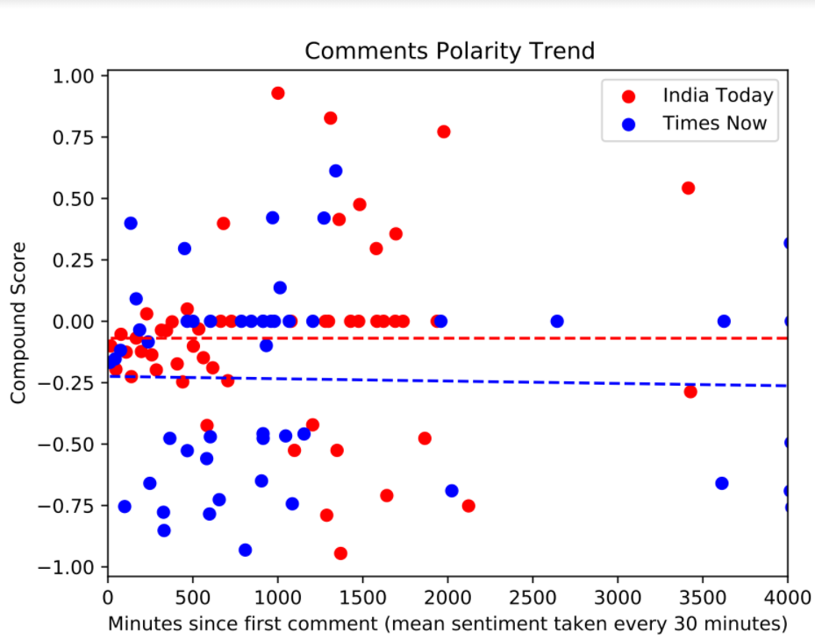

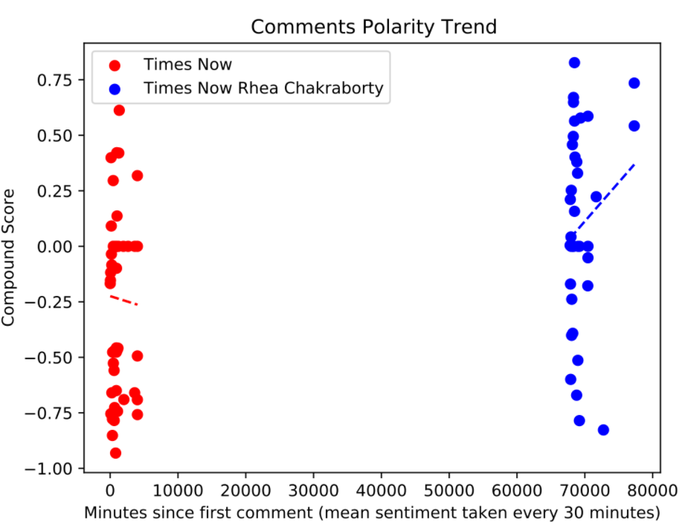

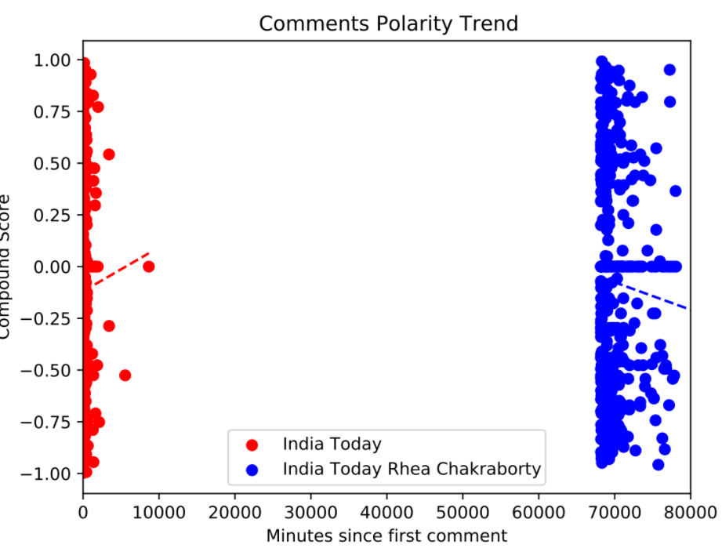

Farmers’ Protest

(September)

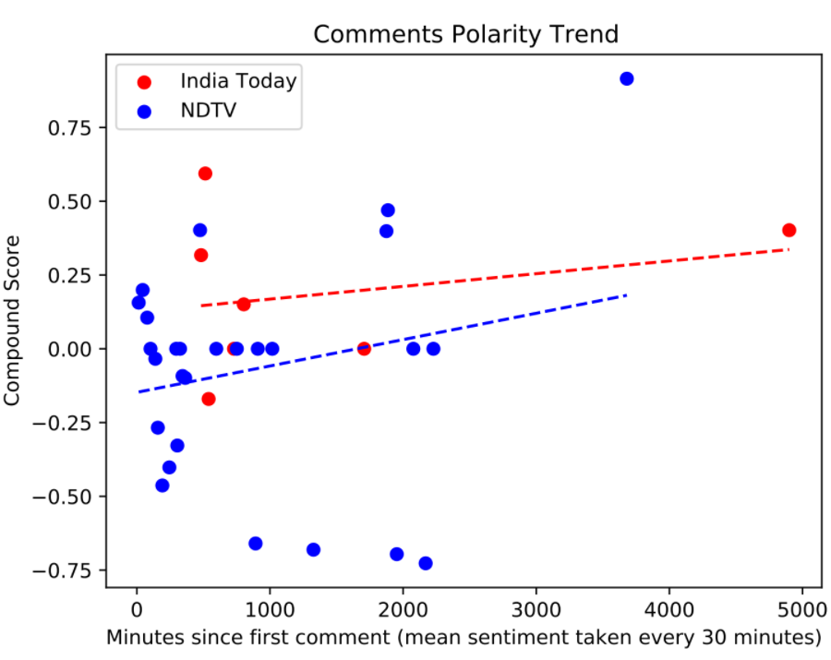

(November: Dhaba offers free food to protestors)

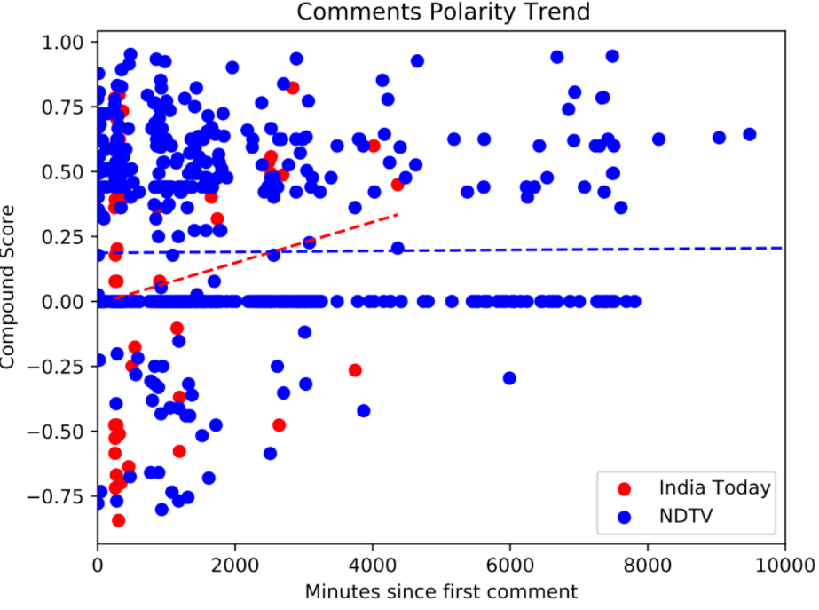

(December: Demand for Bharat Bandh)

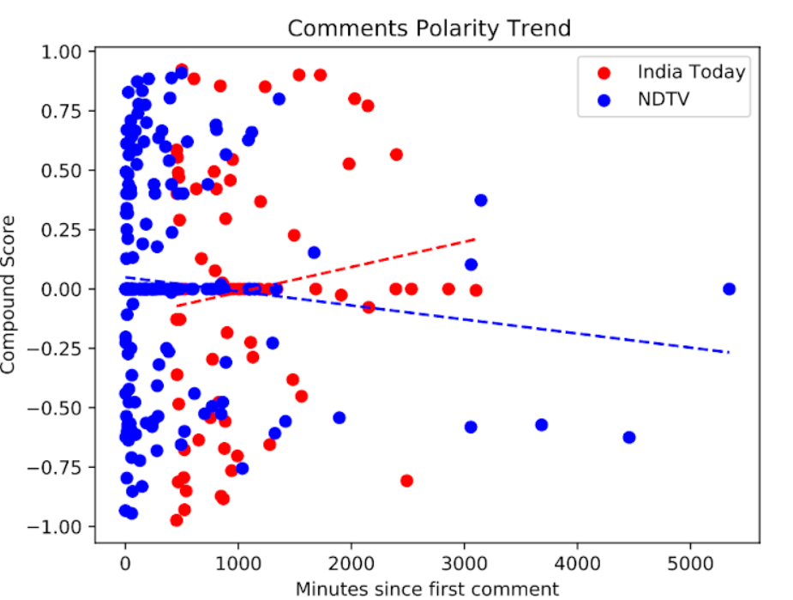

(January: Red Fort Approach)

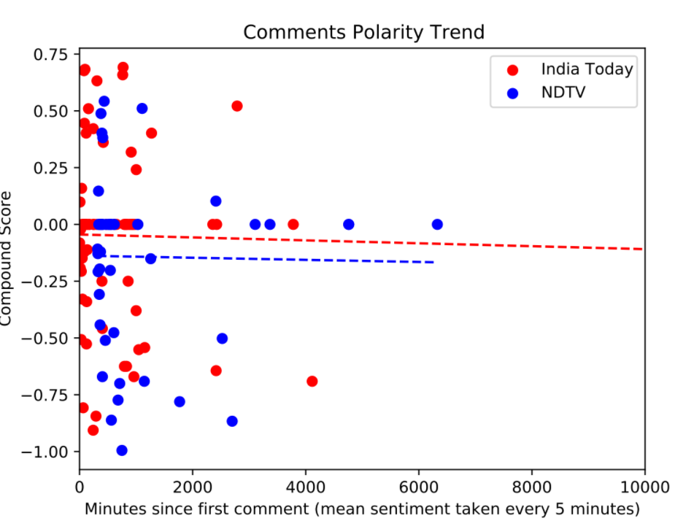

(January: SFJ)

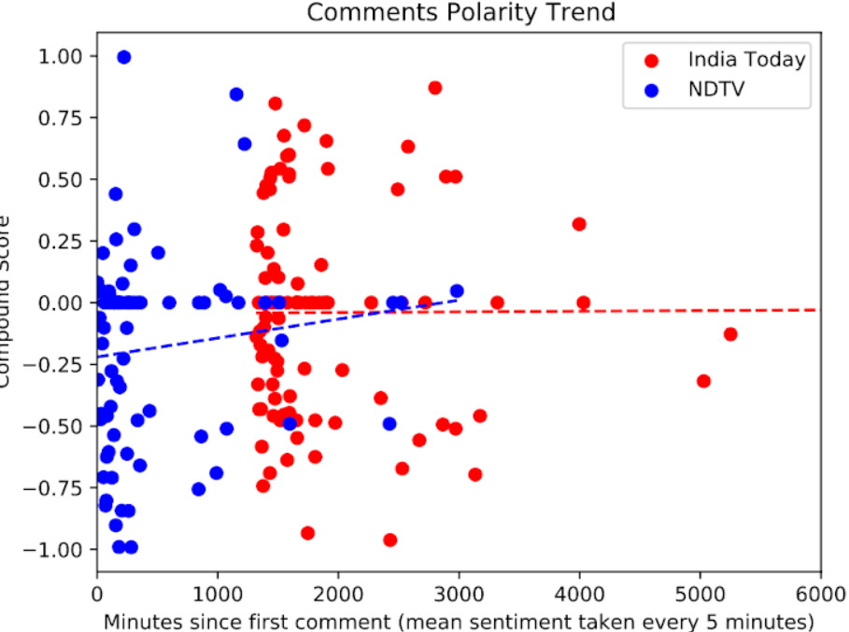

Neeraj Chopra

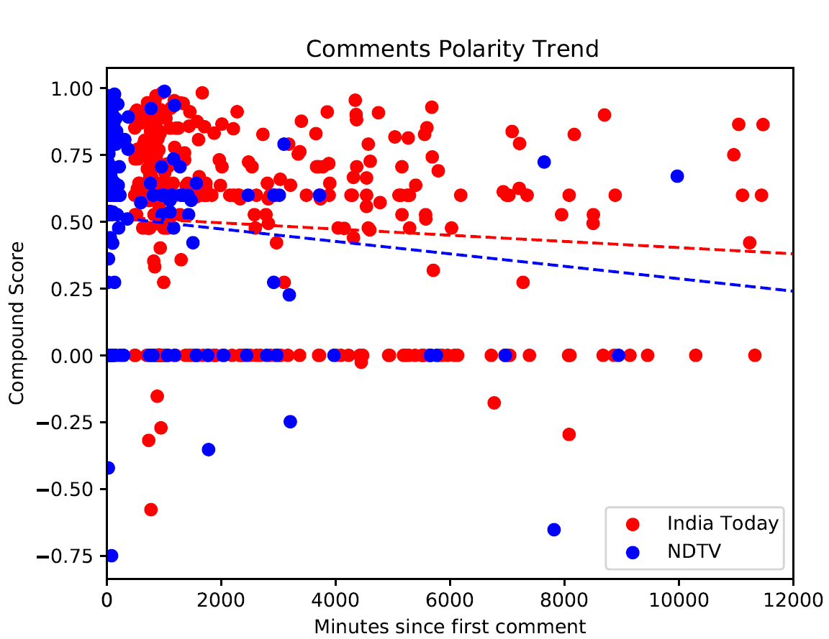

#### Tone Frequency plots

Sushan Singh Rajput

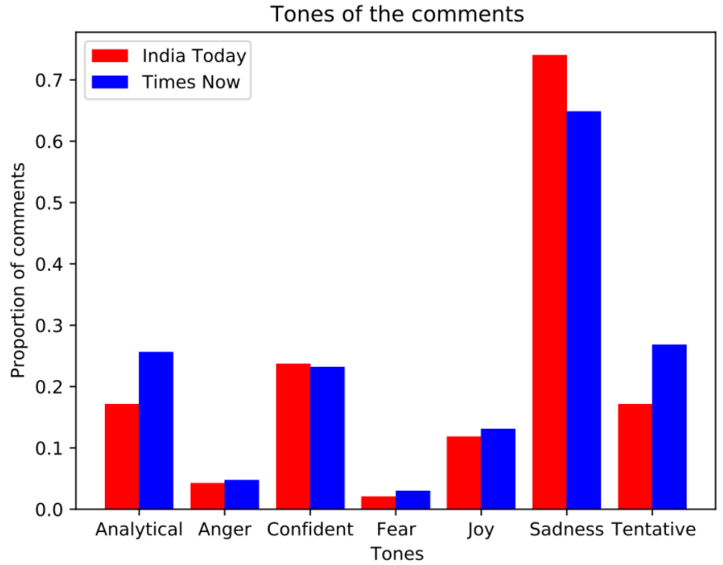

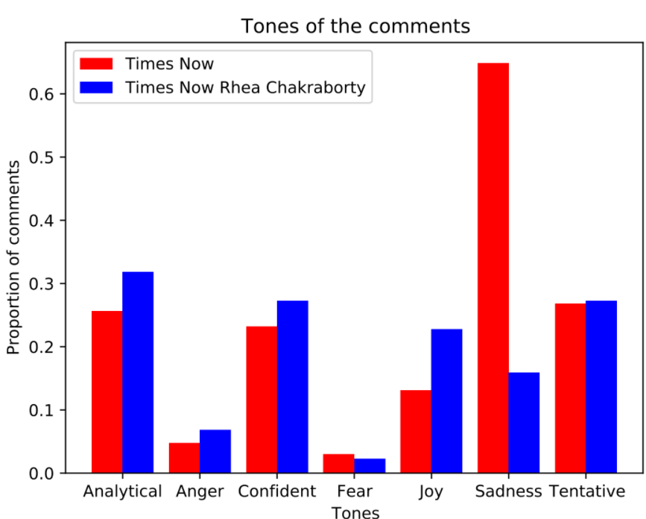

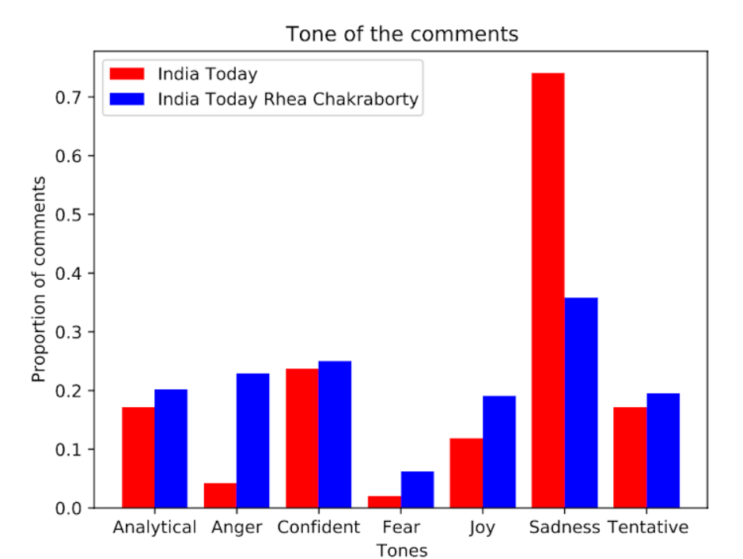

Farmers’ Protest

(September)

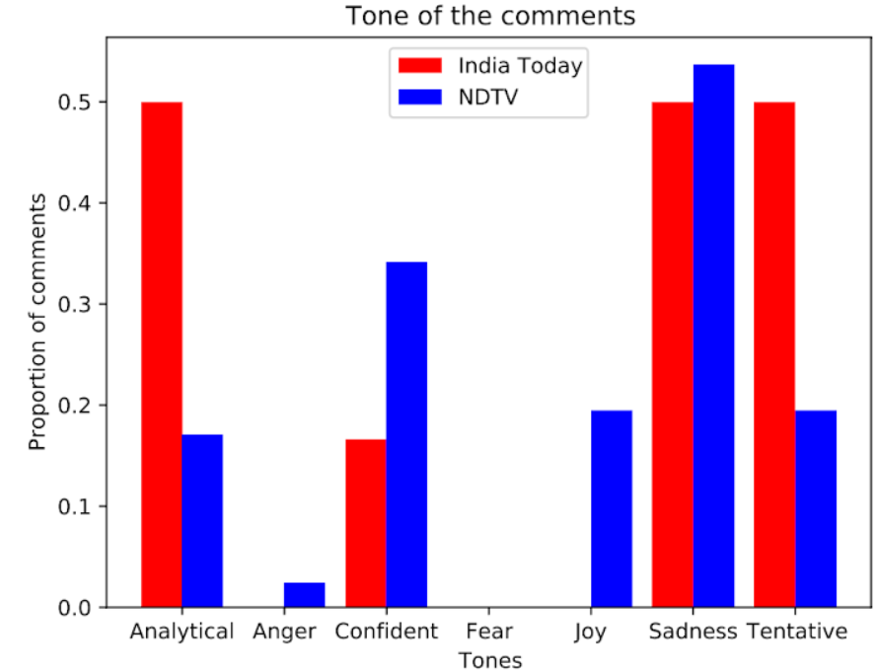

(December)

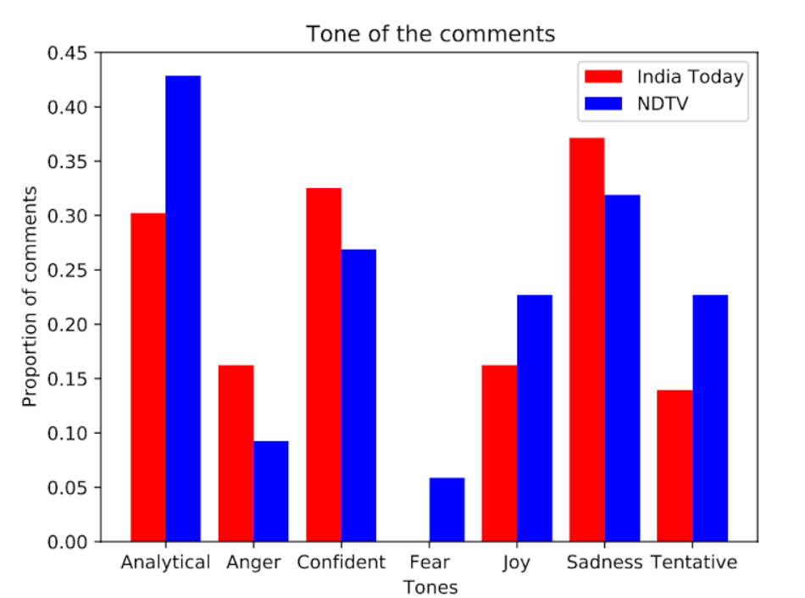

(January Red Fort Approach)

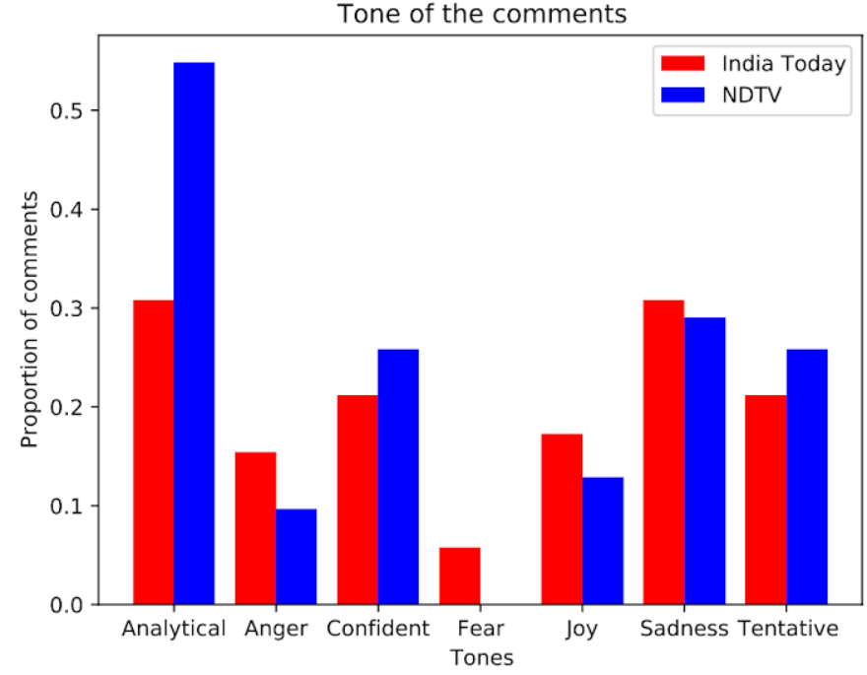

(January SFJ)

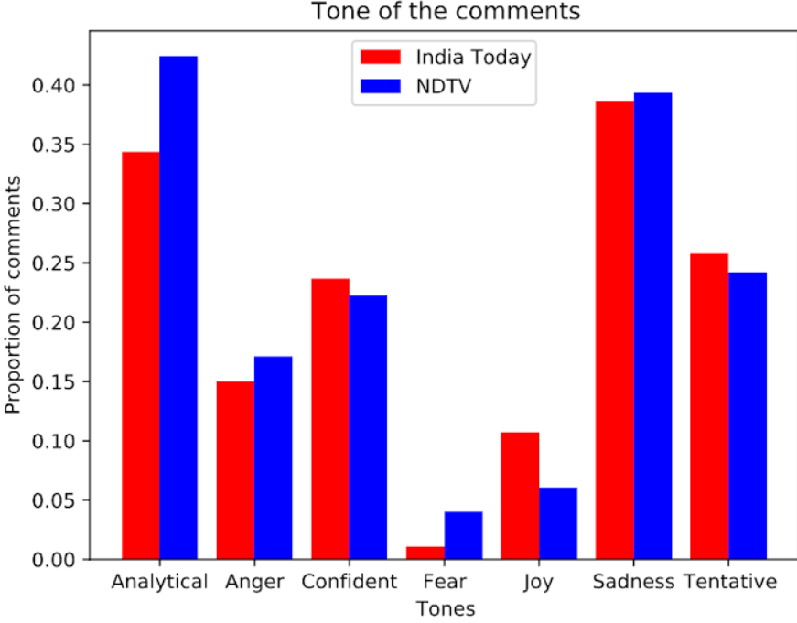

Neeraj Chopra

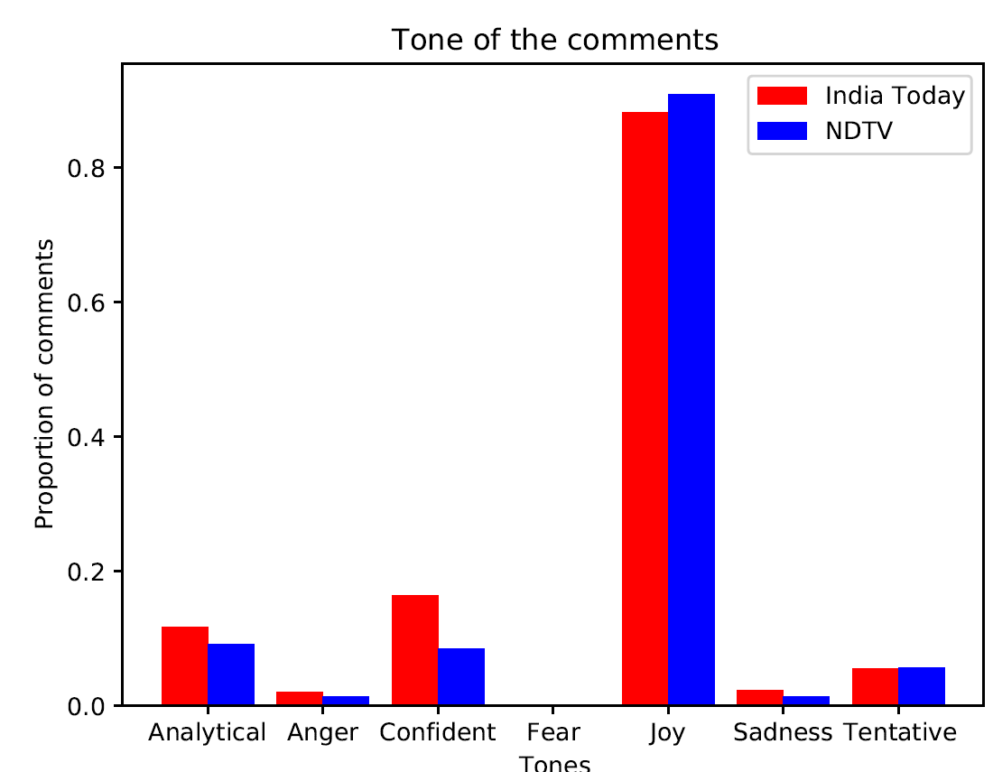

* In the case of Times Now SSR the anger is less and sadness is much more, but in case of Rhea, anger tone is higher and sadness is much less. Analytical tone is more in case of Rhea.
* Anger tone increased significantly when Farmers’ Protest news about Red fort and SFJ came about. Also, Analytical tone increases significantly for NDTV but decreases for India Today.

### **YouTube**

#### Vader results

Sushan Singh Rajput

|  | **Compound** | **Positive** | **Negative** |
| --- | --- | --- | --- |
| **India Today** | -0.09980066225 | 0.1301589404 | 0.1996622517 |
| **Times Now** | 0.049405 | 0.16562 | 0.13992 |
| **NDTV English** | 0.0605535 | 0.1305 | 0.10381 |
| **NDTV Hindi** | 0.0108582 | 0.118056 | 0.122 |
| **India Today Rhea** | -0.006611042945 | 0.107208589 | 0.1298404908 |
| **Times Now Rhea** | -0.05101290323 | 0.1245645161 | 0.1319032258 |
| **NDTV Rhea** | 0.245463 | 0.22256 | 0.08441 |

Farmers’ Protest, September ‘20

|  | **Compound** | **Positive** | **Negative** |
| --- | --- | --- | --- |
| **India Today** | 0.09210827068 | 0.1257368421 | 0.08520300752 |
| **NDTV** | 0.07017073474 | 0.1049651308 | 0.03403486924 |

Farmers’ Protest, November ‘20

|  | **Compound** | **Positive** | **Negative** |
| --- | --- | --- | --- |
| **India Today** | -0.03969 | 0.1172 | 0.13976 |
| **NDTV** | 0.06781535381 | 0.1039599466 | 0.04448064085 |

Farmers’ Protest, December ‘20

|  | **Compound** | **Positive** | **Negative** |
| --- | --- | --- | --- |
| **India Today** | -0.129583 | 0.06373 | 0.09577 |
| **NDTV** | 0.1703802595 | 0.1539953661 | 0.03494717331 |

Farmers’ Protest, January ‘20

|  | **Compound** | **Positive** | **Negative** |
| --- | --- | --- | --- |
| **India Today** | 0.00150967509 | 0.08445776173 | 0.08873862816 |
| **NDTV** | -0.01499191011 | 0.08927865169 | 0.08694382022 |
| **India Today Barricade** | -0.04201167513 | 0.08278341794 | 0.09304737733 |
| **NDTV Barricade** | -0.03413574879 | 0.05740338164 | 0.08035024155 |
| **India Today Stone** | -0.03763700906 | 0.09743655589 | 0.1136510574 |
| **NDTV Stone** | -0.05992783505 | 0.1036443299 | 0.1441907216 |
| **India Today Debate** | -0.1671868613 | 0.08513868613 | 0.1588540146 |
| **NDTV Debate** | -0.02338669663 | 0.06320629213 | 0.06756179775 |

Neeraj Chopra

|  | **Compound** | **Positive** | **Negative** |
| --- | --- | --- | --- |
| **India Today** | 0.3686436578  (0.55542) | 0.2928318584 | 0.02319469027 |
| **NDTV** | 0.3648642857  (0.53456) | 0.2762698413 | 0.02653968254 |

* India Today vs NDTV: SSR <. SSR Rhea <. Farmers’ Sept >. Farmers’ Nov <. Farmers’ Dec <. Farmers’ Jan >. Farmers’ Jan Barricade <. Farmers’ Jan Stones >. Farmers’ Jan Debate <. **6 lesser. 3 more**

#### Trend

Sushan Singh Rajput

|  | 5 Mins | 10 Mins | 30 Mins |
| --- | --- | --- | --- |
| **India Today** | 1 | 1 | 1 |
| **Times Now** | 4 | 4 | 4 |
| **NDTV English** | 3 | 3 | -2 |
| **NDTV Hindi** | 1 | 1 | -2 |
| **India Today Rhea** | -1 | -2 | -2 |
| **Times Now Rhea** | -4 | -4 | -3 |
| **NDTV Rhea** | -3 | -2 | -1 |

Farmers’ Protest

|  | 5 Mins | 10 Mins | 30 Mins |
| --- | --- | --- | --- |
| **India Today** | -1 | -1 | -1 |
| **Times Now** |  |  |  |
| **NDTV English** | -4 | -4 | -4 |

#### Sentiment trend plots

Sushan Singh Rajput

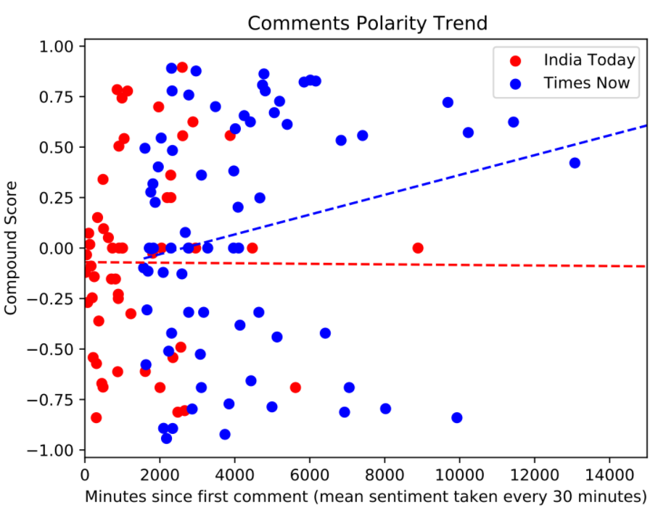

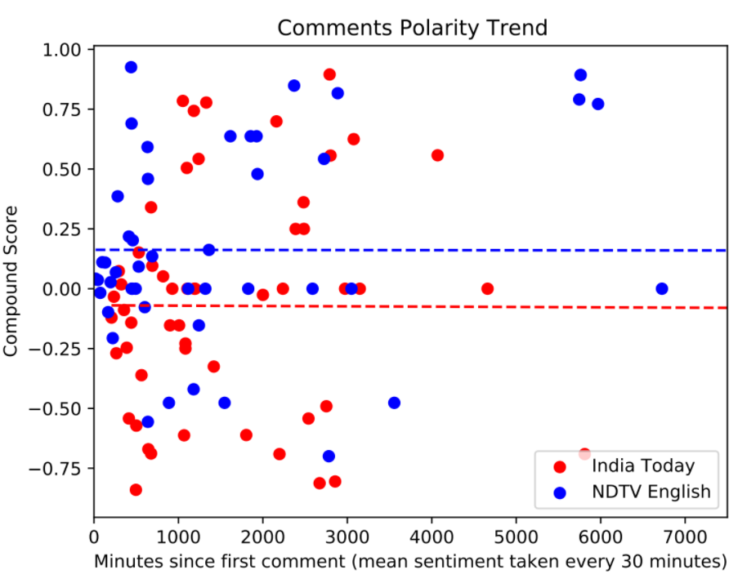

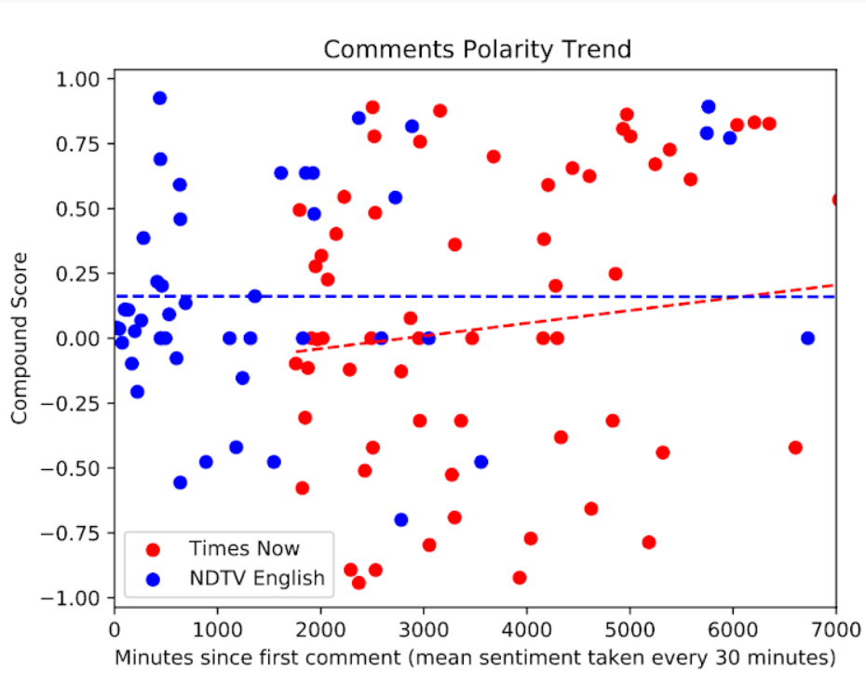

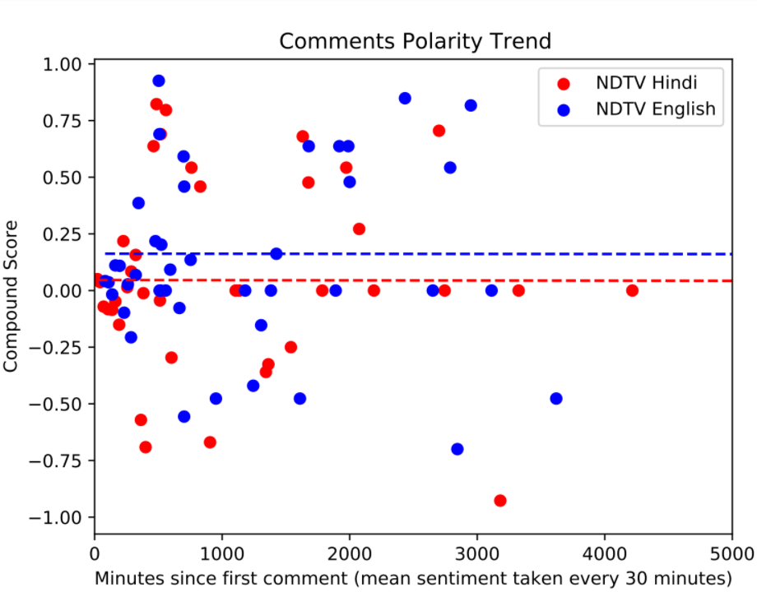

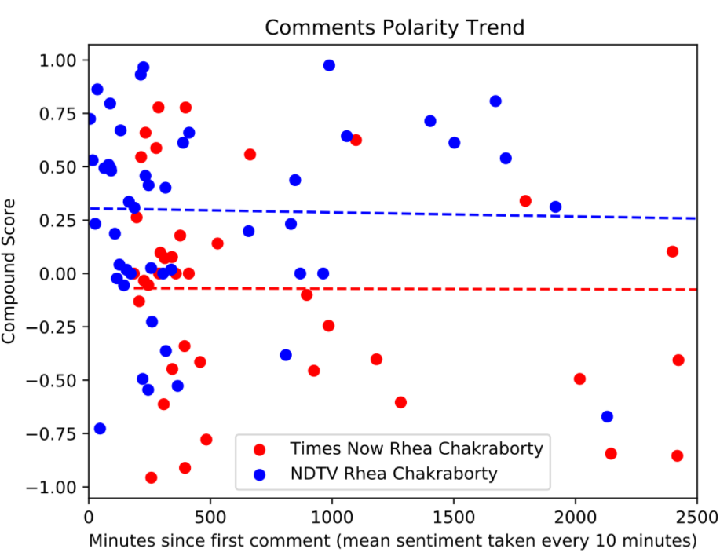

Farmers’ Protest

(September)

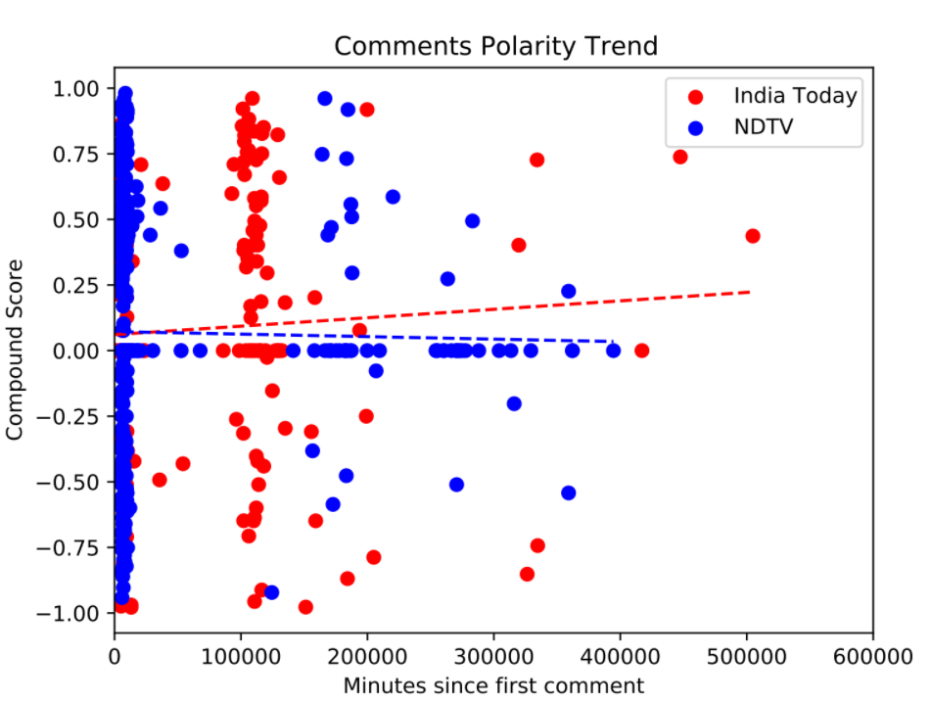

(November)

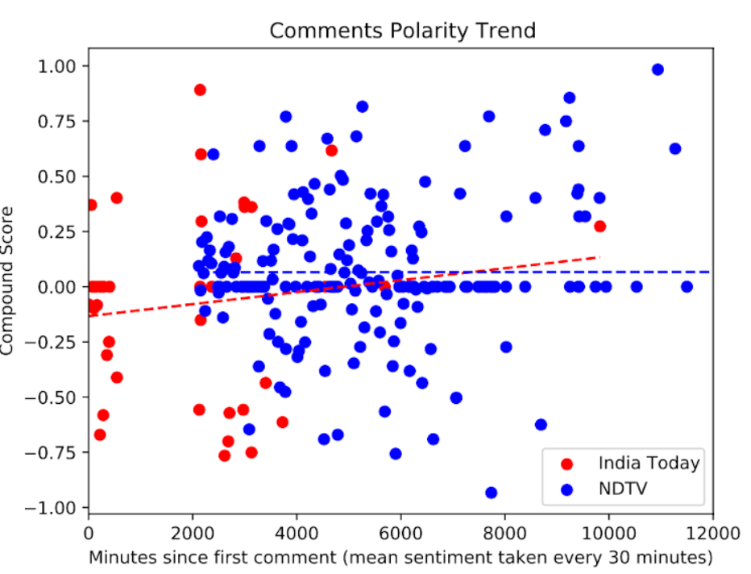

(December)

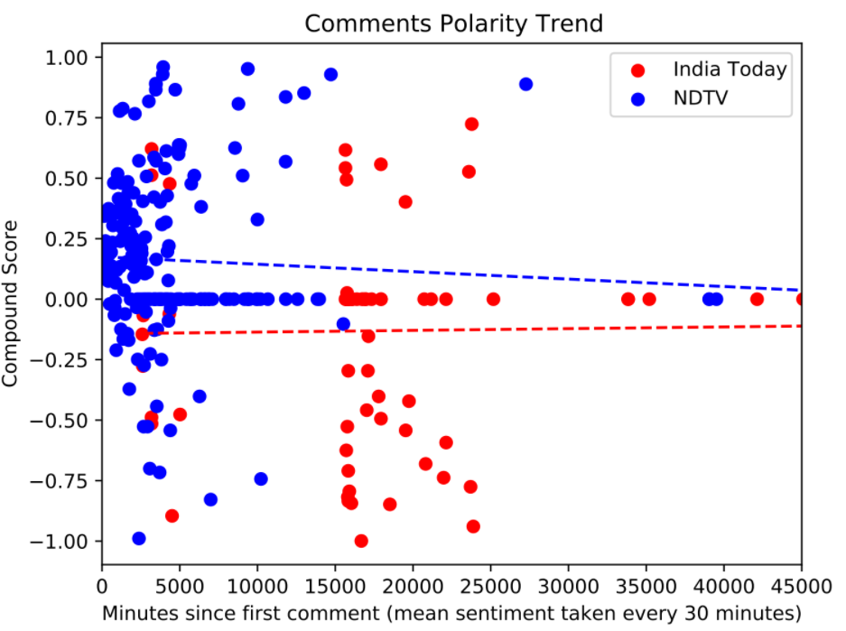

(January)

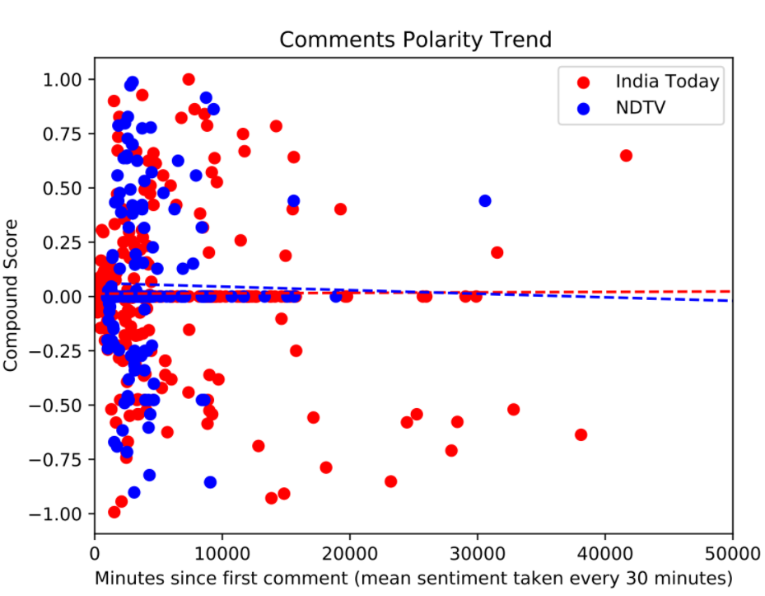

(January: Barricade breaking)

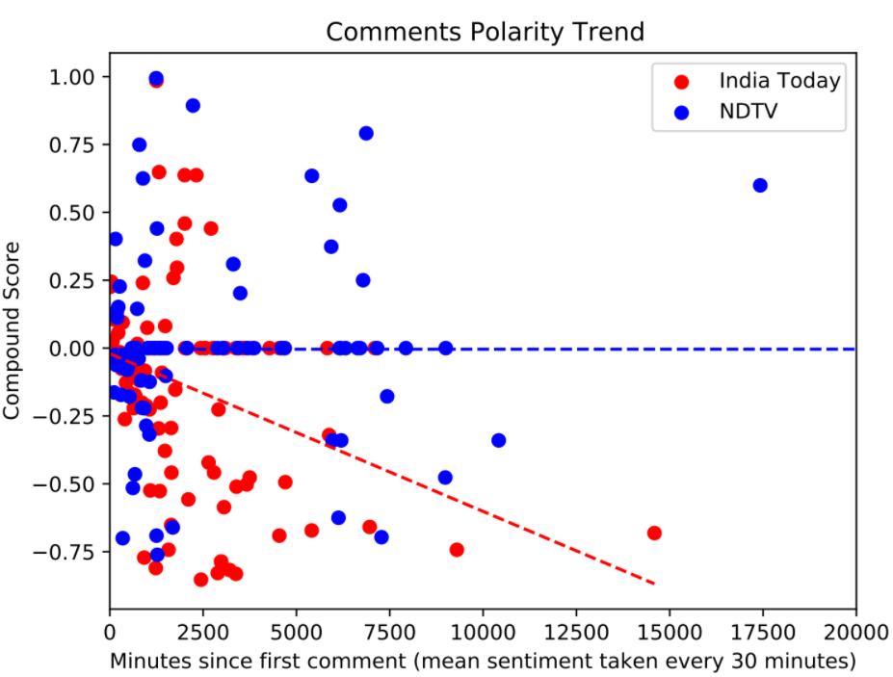

(January: Stone pelting, Tear gas)

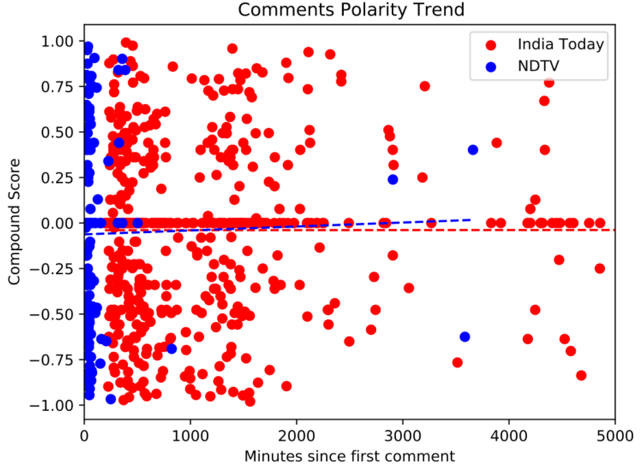

(January: Debate)

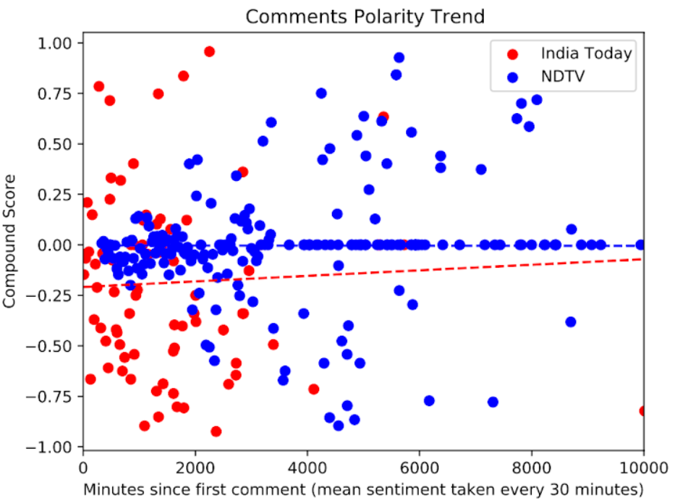

Neeraj Chopra

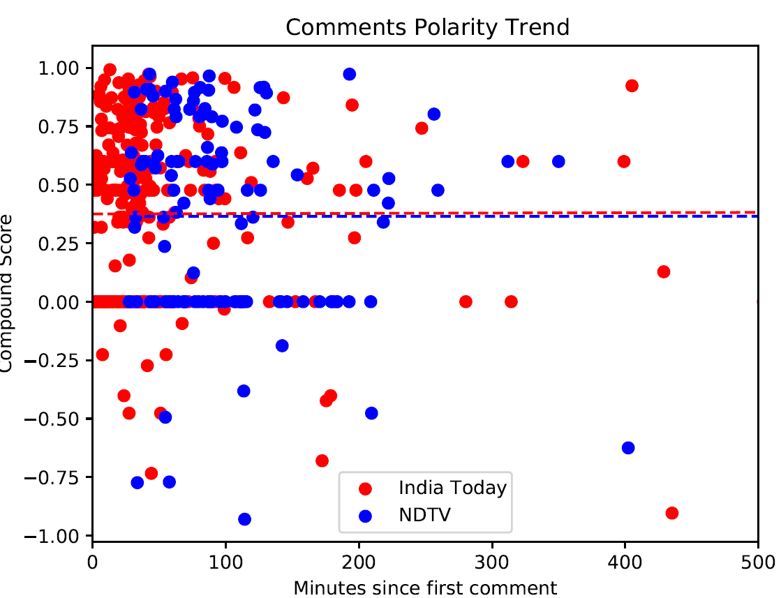

* For Stan Swamy and SSR and a few videos of the Farmers’ Protest **NDTV** sentiment trend is more positive than **India Today**.

#### Tone Frequency plots

Sushan Singh Rajput

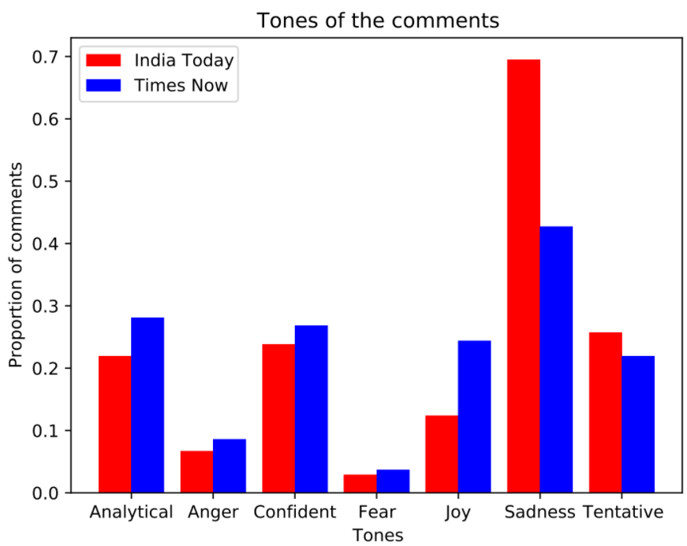

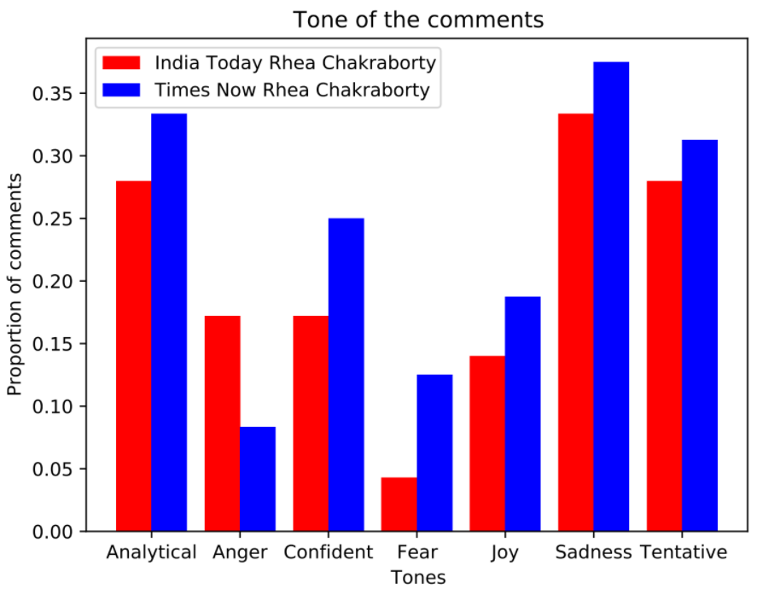

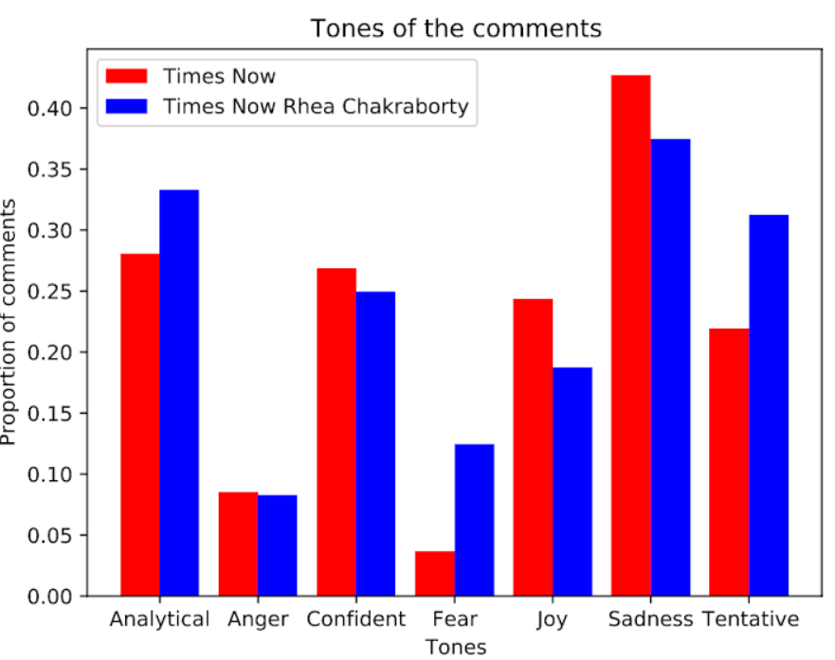

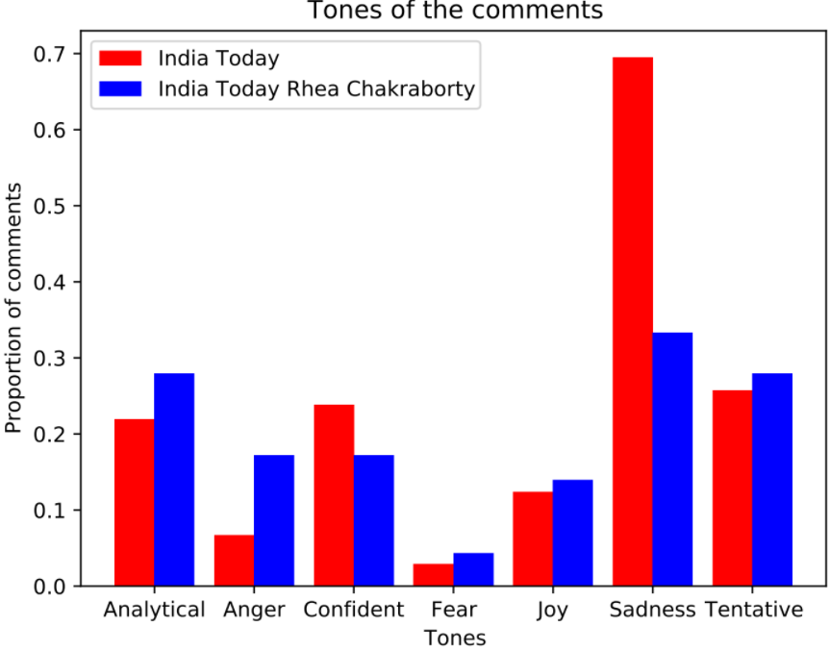

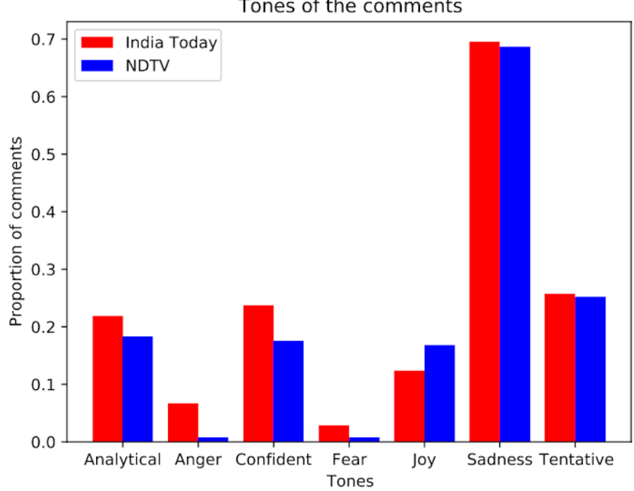

Farmers’ Protest

(September)

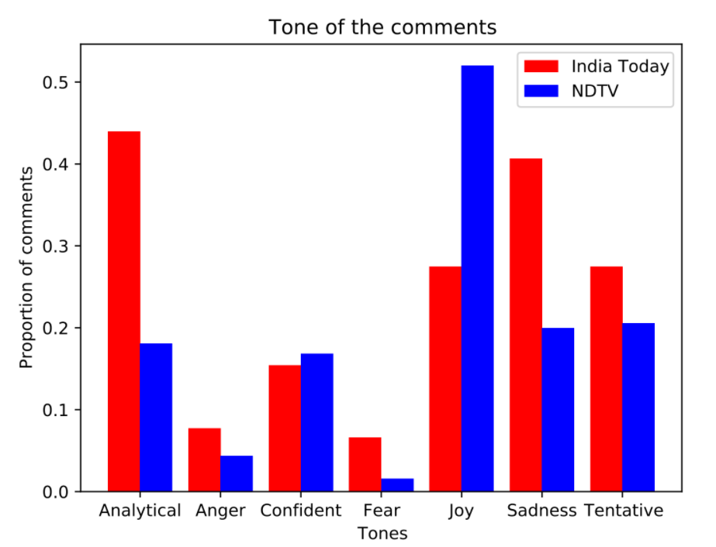

Farmers’ Protest

(November)

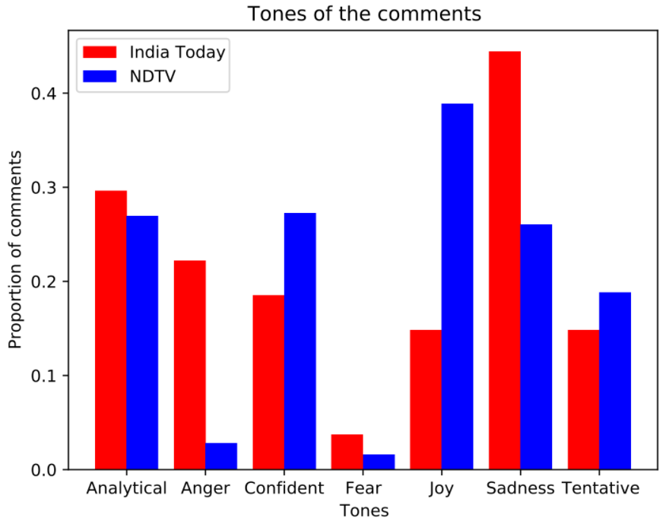

Farmers’ Protest

(December)

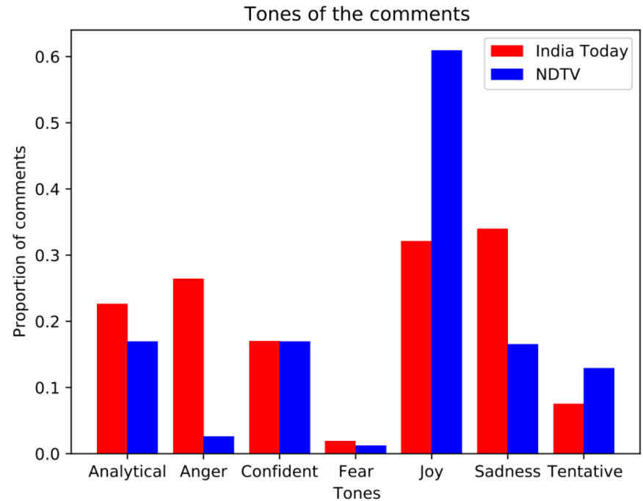

Farmers’ Protest

(January)

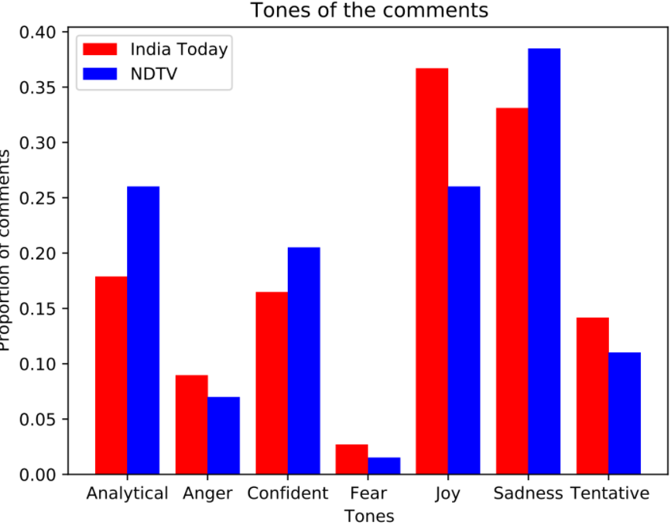

Neeraj Chopra

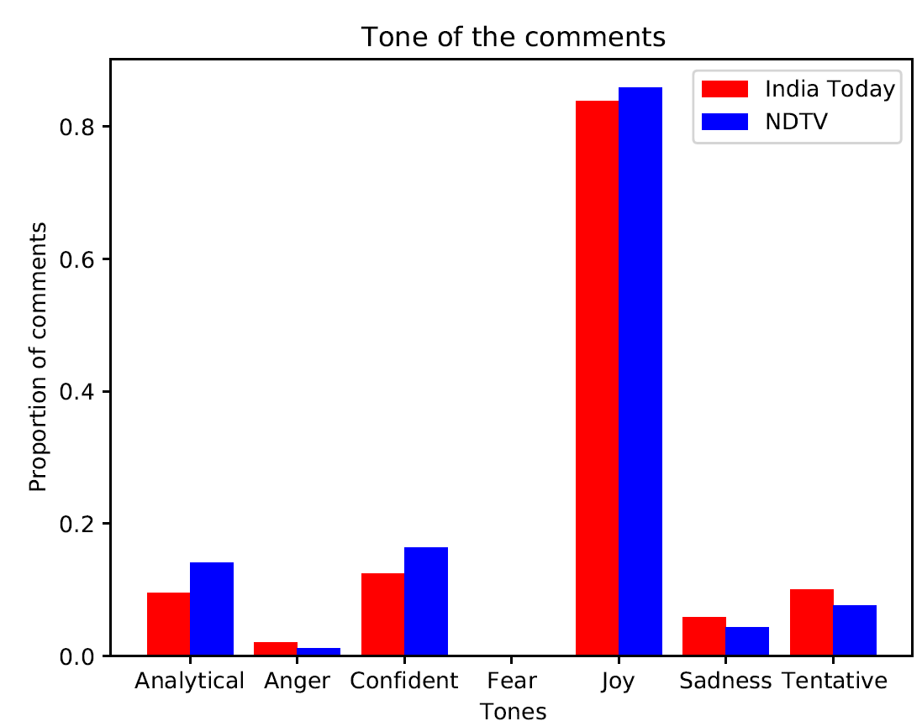

* India Today has less Analytical/Fear/Joy comments than Times Now in case of SSR.
* India Today has more Analytical/Anger comments than NDTV for SSR and Farmers’ Protest except in the month of January
* India Today the anger tone is more than NDTV in all cases and sadness in most.
* Times now sadness tone in SSR is slightly more than Rhea Chakraborty
* India Today sadness tones is more and anger is lesser than Rhea Chakraborty
* India Today and Times Now have lesser Analytical/Tentative/Fear and more Confident tone in case of SSR compared to Rhea Chakraborty
* Analytical tone in Farmers’ Protest declines in Nov, Dec and Jan for India Today but for NDTV increases in Nov, decreases in Dec and increases in Jan.

## **Different platform, same media outlets:**

### **India Today**

#### Vader results

Sushan Singh Rajput

|  | **YouTube** | | | **Facebook** | | |
| --- | --- | --- | --- | --- | --- | --- |
|  | **Compound** | **Positive** | **Negative** | **Compound** | **Positive** | **Negative** |
| **India Today** | -0.09980066225 | 0.1301589404 | 0.1996622517 | -0.1157481522 | 0.109925 | 0.2118521739 |

Farmers’ Protest

(September)

|  | **YouTube** | | | **Facebook** | | |
| --- | --- | --- | --- | --- | --- | --- |
|  | **Compound** | **Positive** | **Negative** | **Compound** | **Positive** | **Negative** |
| **India Today** | 0.04427222222 | 0.1013333333 | 0.063 | 0.1886909091 | 0.207 | 0.04890909091 |

(November: Amit Shah appeals for talks)

|  | **YouTube** | | | **Facebook** | | |
| --- | --- | --- | --- | --- | --- | --- |
|  | **Compound** | **Positive** | **Negative** | **Compound** | **Positive** | **Negative** |
| **India Today** | -0.046305 | 0.0964 | 0.13185 | -0.07795208333 | 0.07189583333 | 0.09260416667 |

(December)

|  | **YouTube** | | | **Facebook** | | |
| --- | --- | --- | --- | --- | --- | --- |
|  | **Compound** | **Positive** | **Negative** | **Compound** | **Positive** | **Negative** |
| **India Today** | 0.01509130435 | 0.1220434783 | 0.08113043478 | -0.01002235294 | 0.1112941176 | 0.08270588235 |

(January: Death of a protestor)

|  | **YouTube** | | | **Facebook** | | |
| --- | --- | --- | --- | --- | --- | --- |
|  | **Compound** | **Positive** | **Negative** | **Compound** | **Positive** | **Negative** |
| **India Today** | -0.017 | 0.0976 | 0.1159833333 | -0.110059322 | 0.09079661017 | 0.1180847458 |

Neeraj Chopra

|  | **YouTube** | | | **Facebook** | | |
| --- | --- | --- | --- | --- | --- | --- |
|  | **Compound** | **Positive** | **Negative** | **Compound** | **Positive** | **Negative** |
| **India Today** | 0.3686436578  (0.55542) | 0.2928318584 | 0.02319469027 | 0.4733440722  (0.64668) | 0.4810541237 | 0.008226804124 |

#### Sentiment trend plots

Sushan Singh Rajput

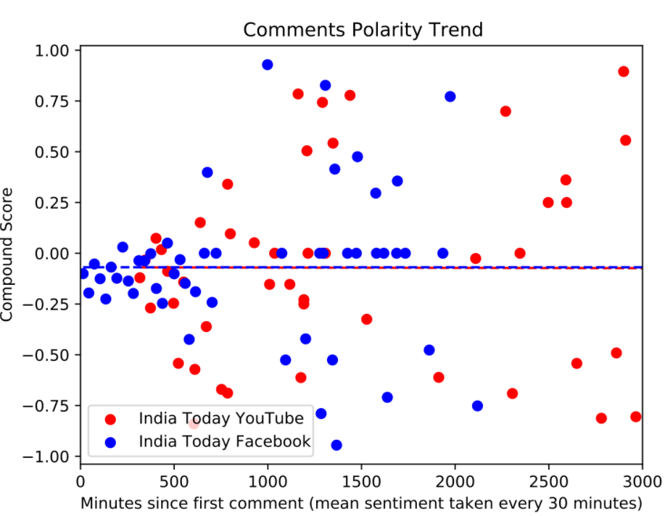

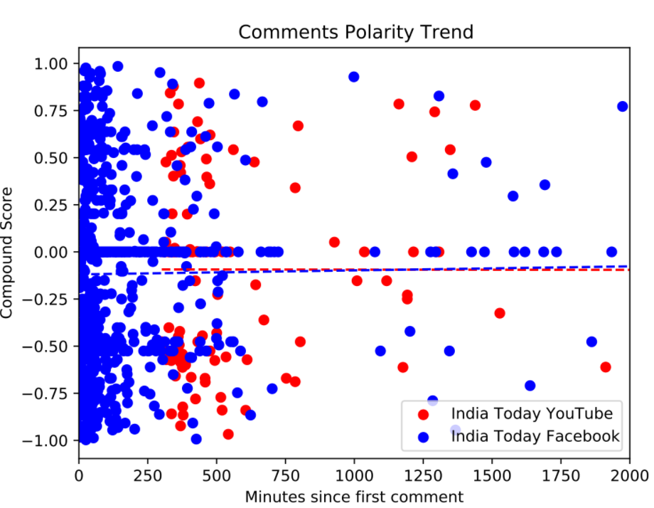

Farmers’ Protest

(September)

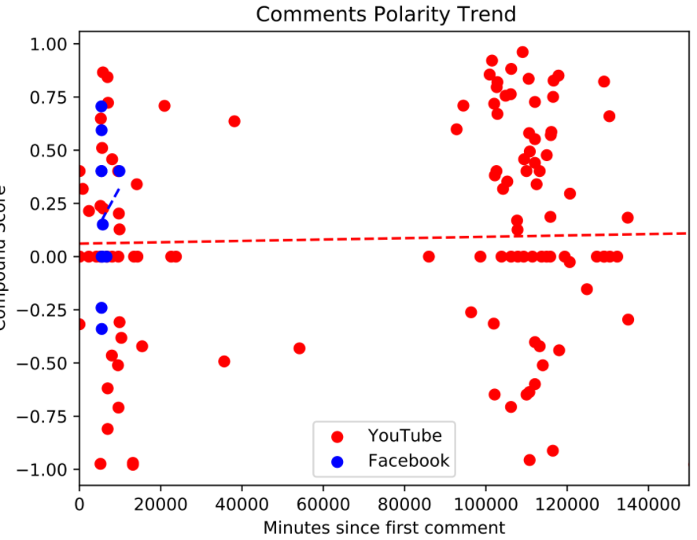

(November: Amit Shah appeals for talks)

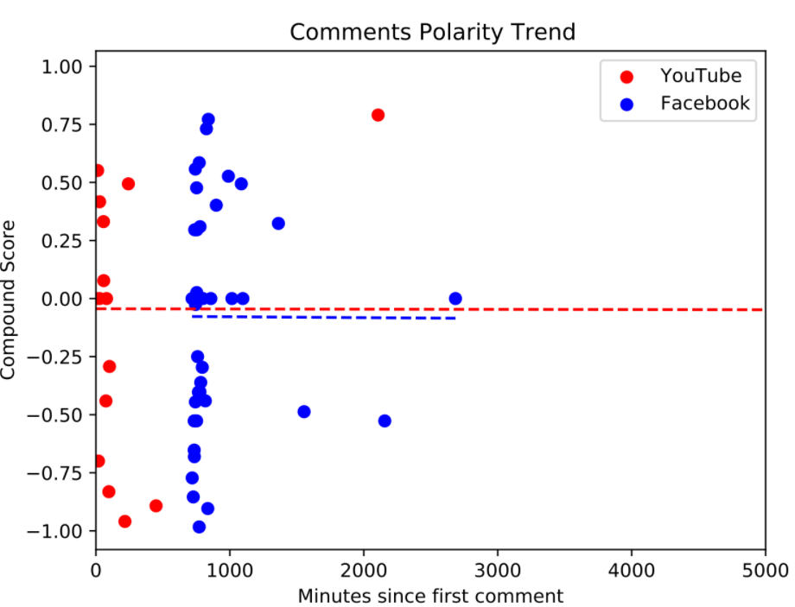

(December)

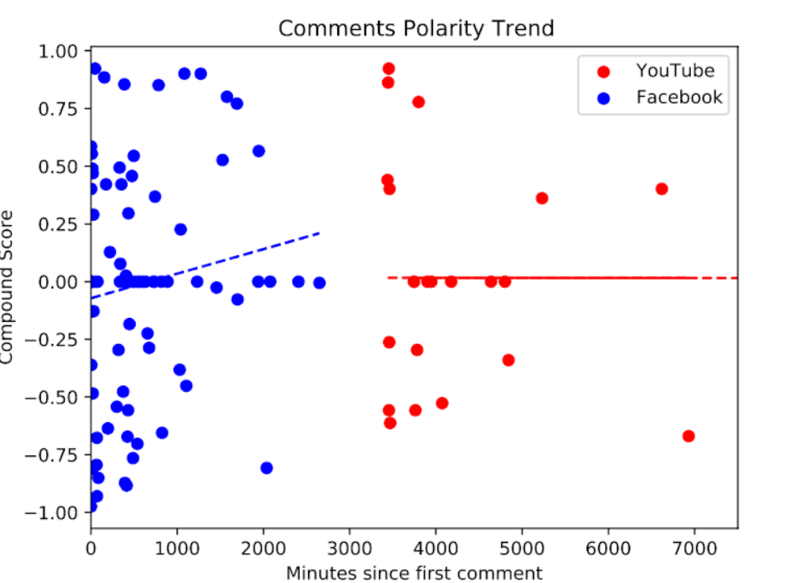

(January: Death of a protestor)

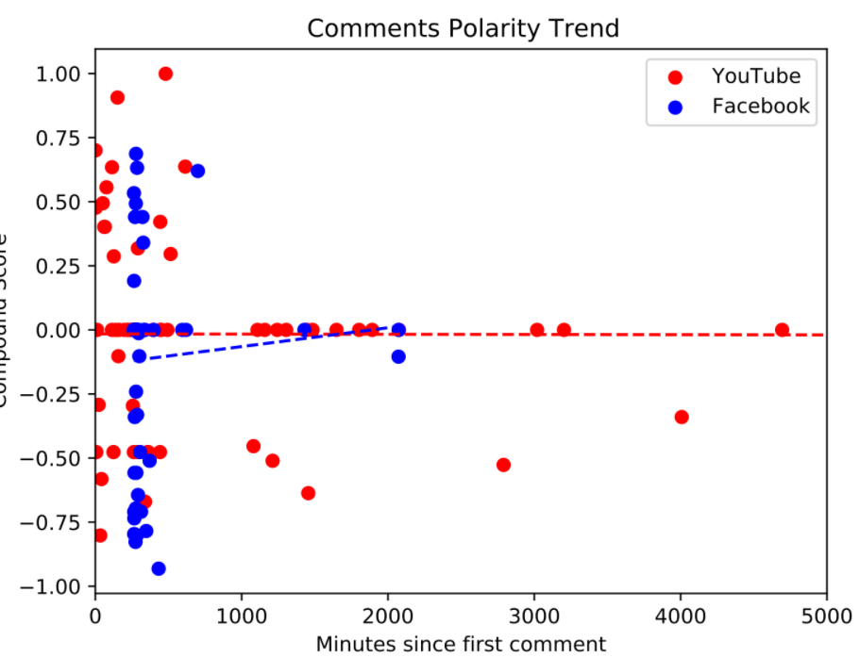

Neeraj Chopra

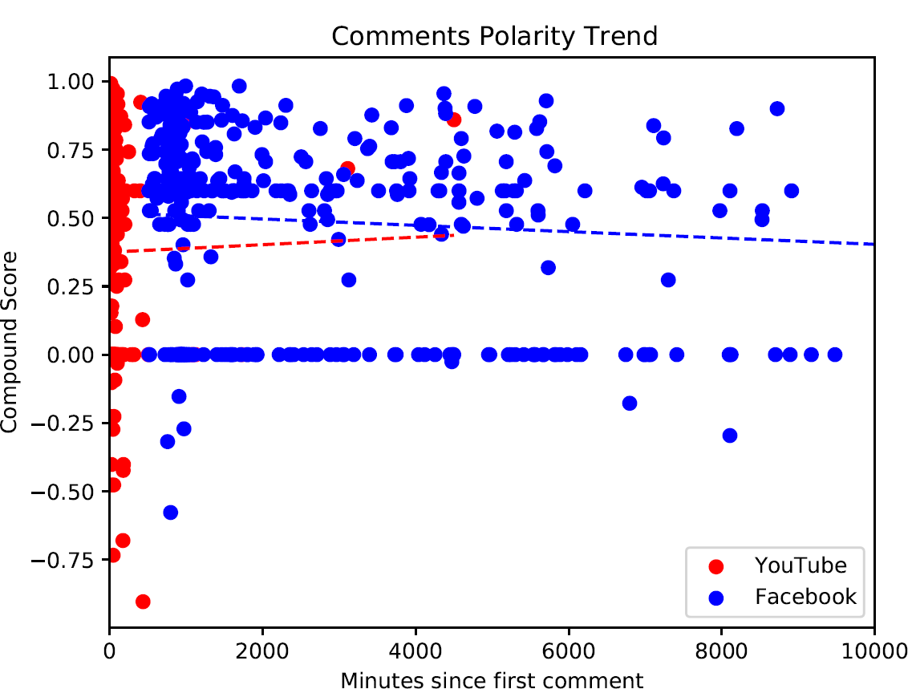

#### Tone Frequency plots

Sushan Singh Rajput

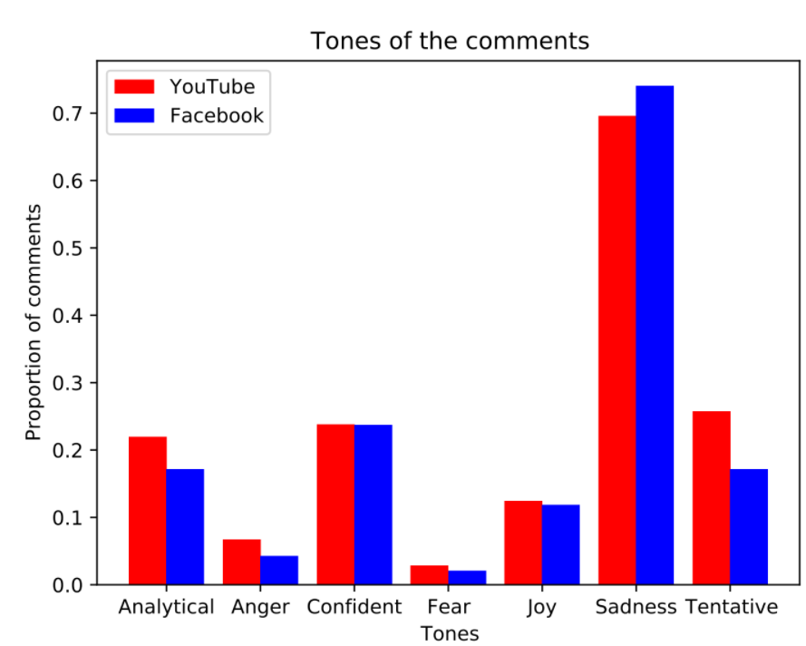

Farmers’ Protest

September

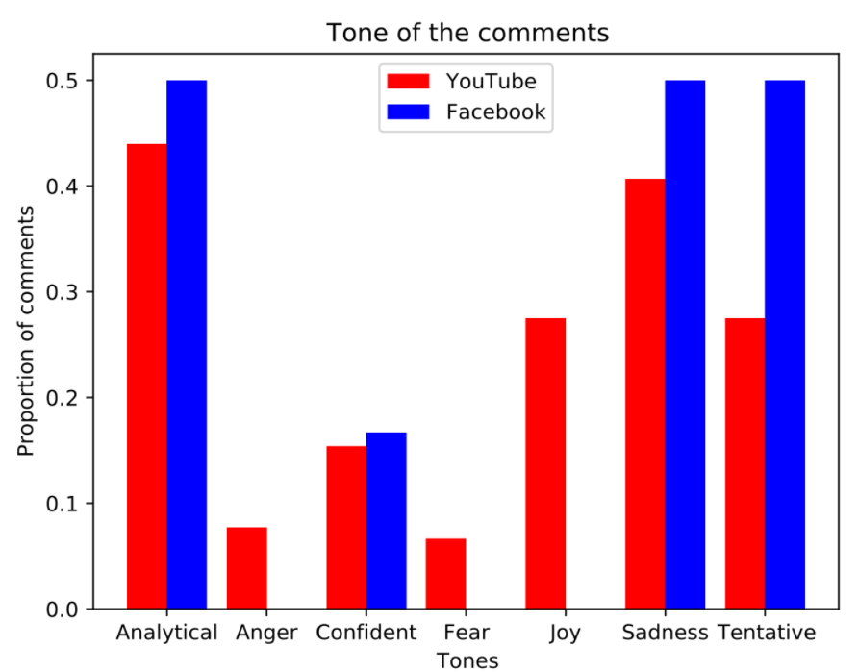

December: Bharat Bandh

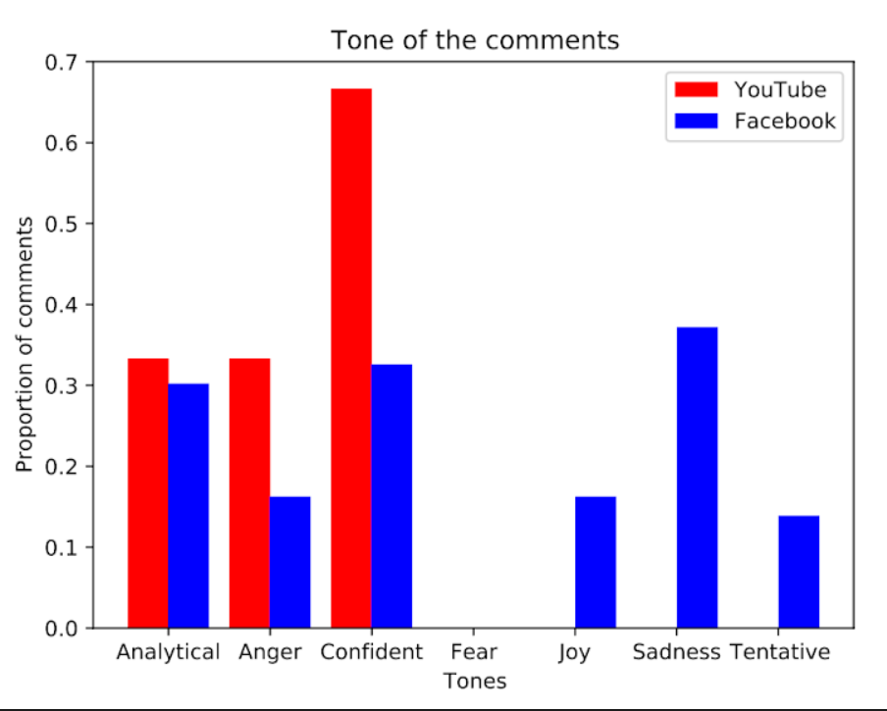

January: Death of a protestor

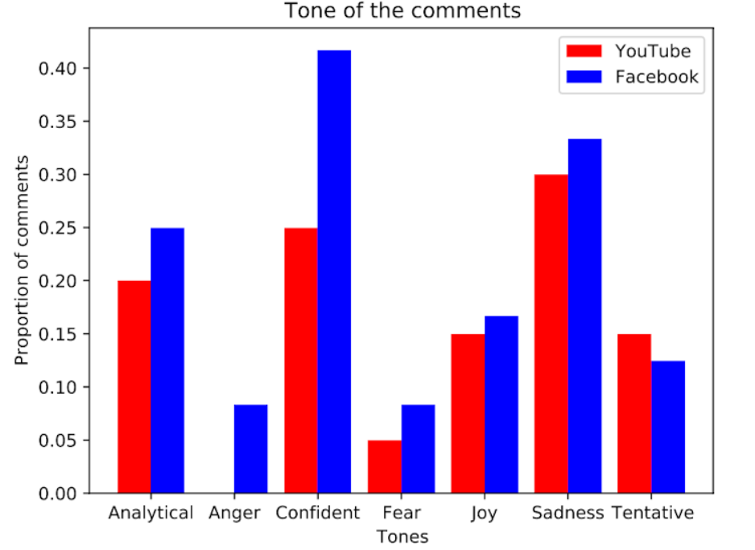

Neeraj Chopra

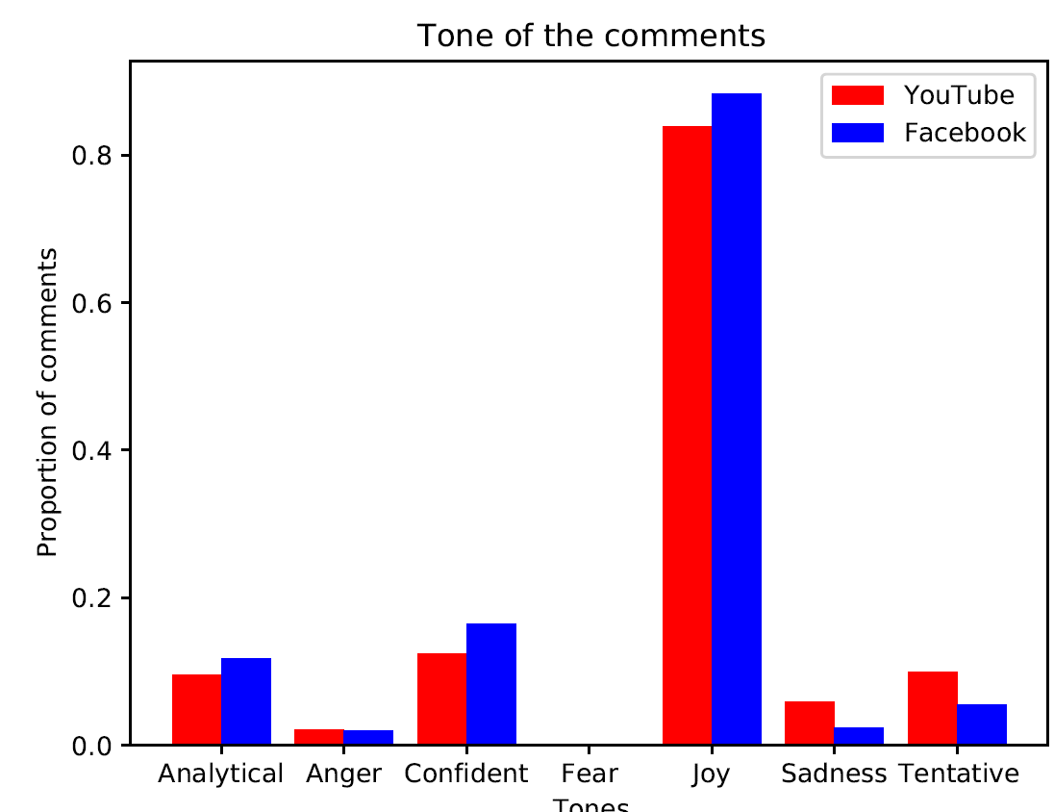

### **Times Now**

#### Vader results

Sushan Singh Rajput

|  | **YouTube** | | | **Facebook** | | |
| --- | --- | --- | --- | --- | --- | --- |
|  | **Compound** | **Positive** | **Negative** | **Compound** | **Positive** | **Negative** |
| **Times Now** | 0.049405 | 0.16562 | 0.13992 | -0.1606233333 | 0.1077708333 | 0.2237375 |
| **Times Now Rhea** | -0.05101290323 | 0.1245645161 | 0.1319032258 | 0.06314556962 | 0.1143417722 | 0.09846835443 |

* Times Now on YouTube is more positive in case of SSR than Rhea angle, compared to Facebook.

#### **Sentiment trend plots**

Sushant Singh Rajput

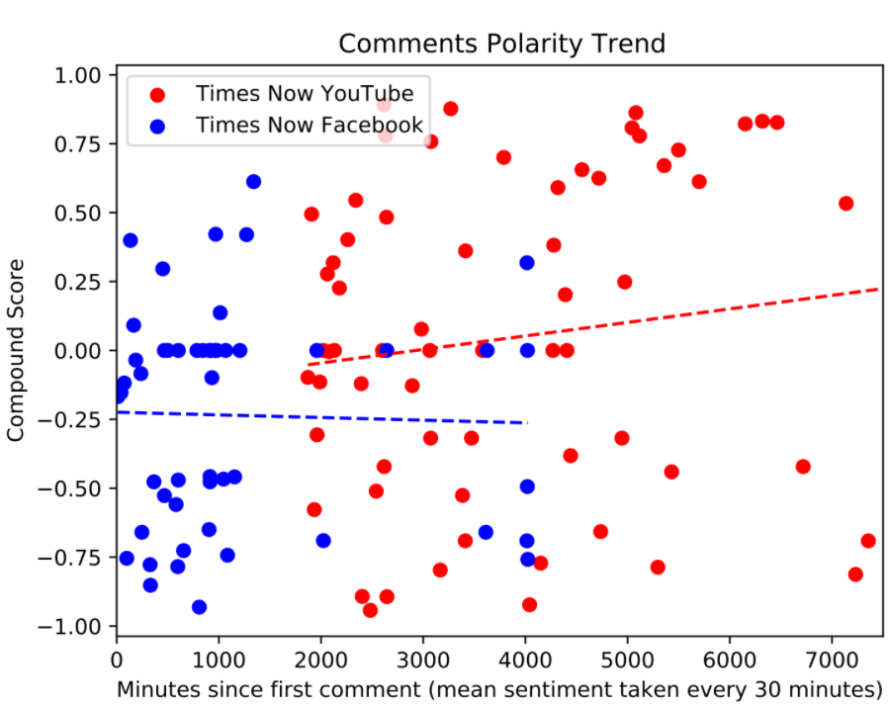

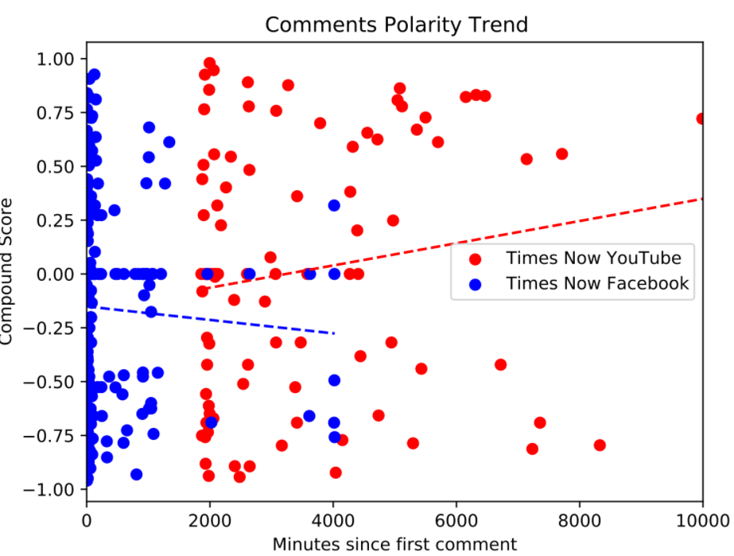

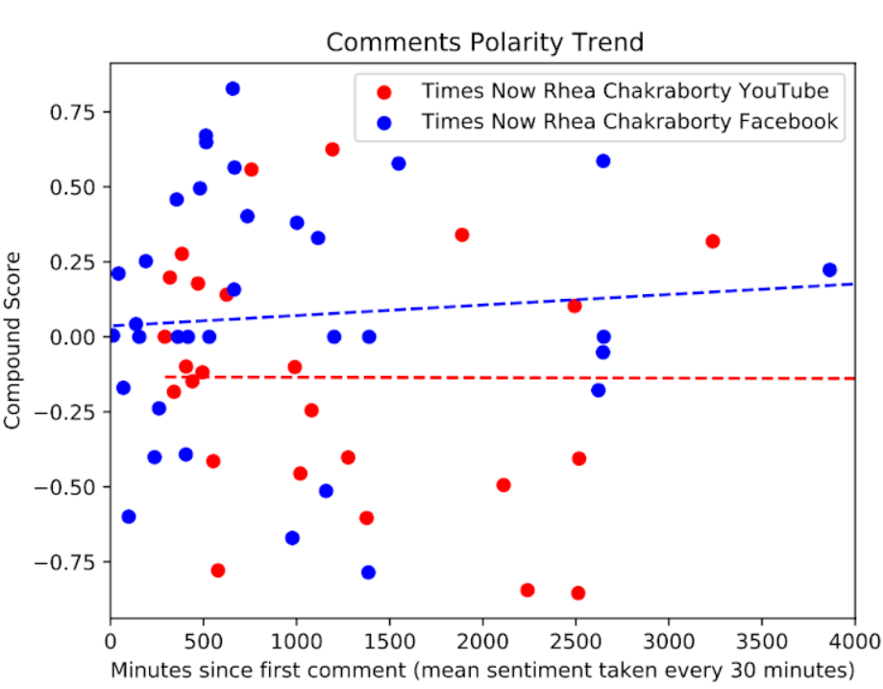

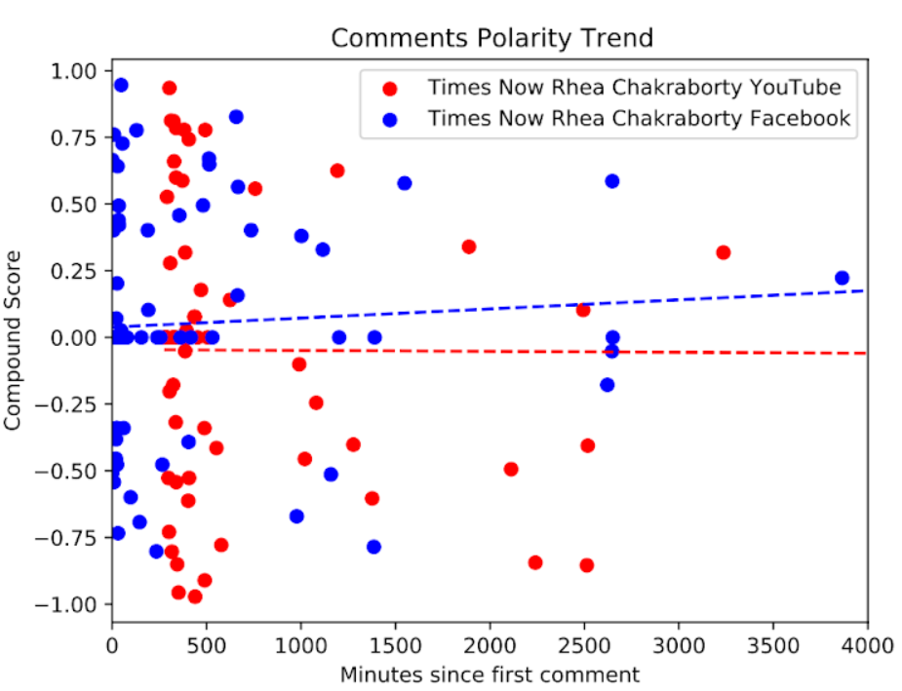

#### Tone Frequency plots

Sushant Singh Rajput

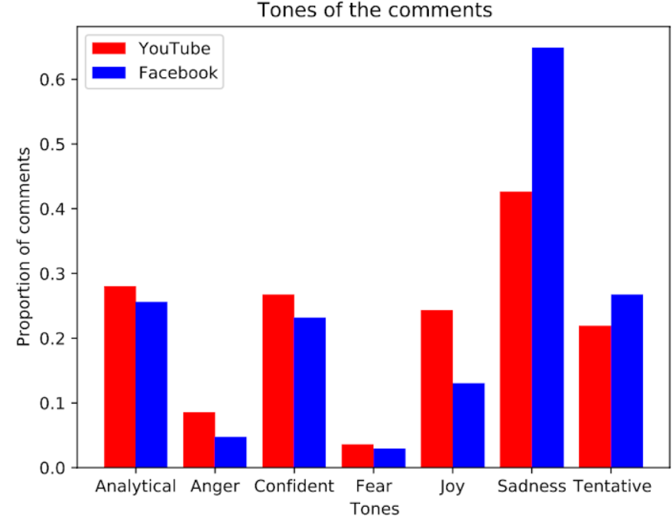

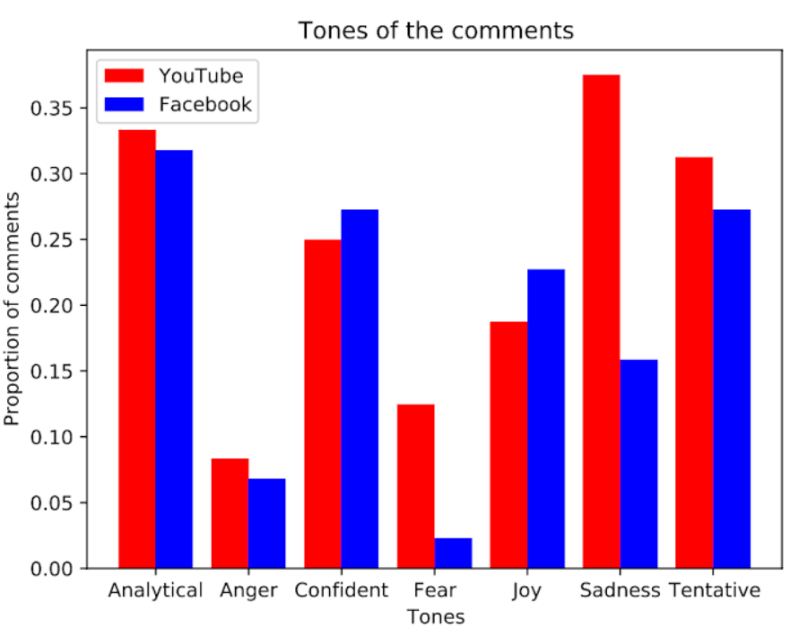

### NDTV

#### Vader results

Sushant Singh Rajput

|  | **YouTube** | | | **Facebook** | | |
| --- | --- | --- | --- | --- | --- | --- |
|  | **Compound** | **Positive** | **Negative** | **Compound** | **Positive** | **Negative** |
| **NDTV** | 0.0605535 | 0.1305 | 0.10381 | -0.0826 | 0.08360869565 | 0.1393695652 |

Farmers’ Protest

September

|  | **YouTube** | | | **Facebook** | | |
| --- | --- | --- | --- | --- | --- | --- |
|  | **Compound** | **Positive** | **Negative** | **Compound** | **Positive** | **Negative** |
| **NDTV** | -0.00773171521 | 0.07134951456 | 0.08575404531 | 0.03307567568 | 0.07502702703 | 0.08132432432 |

November

|  | **YouTube** | | | **Facebook** | | |
| --- | --- | --- | --- | --- | --- | --- |
|  | **Compound** | **Positive** | **Negative** | **Compound** | **Positive** | **Negative** |
| **NDTV** | 0.0009279831388 | 0.07725097276 | 0.06745038911 | -0.01064428 | 0.0311796 | 0.0327744 |

December

|  | **YouTube** | | | **Facebook** | | |
| --- | --- | --- | --- | --- | --- | --- |
|  | **Compound** | **Positive** | **Negative** | **Compound** | **Positive** | **Negative** |
| **NDTV** | 0.1703802595 | 0.1539953661 | 0.03494717331 | 0.02515445545 | 0.1166534653 | 0.08652970297 |

January: Red Fort Breached

|  | **YouTube** | | | **Facebook** | | |
| --- | --- | --- | --- | --- | --- | --- |
|  | **Compound** | **Positive** | **Negative** | **Compound** | **Positive** | **Negative** |
| **NDTV** | -0.05167147436 | 0.09667948718 | 0.1151426282 | -0.1022773585 | 0.1145849057 | 0.1458490566 |

January: Reality Check

|  | **YouTube** | | | **Facebook** | | |
| --- | --- | --- | --- | --- | --- | --- |
|  | **Compound** | **Positive** | **Negative** | **Compound** | **Positive** | **Negative** |
| **NDTV** | -0.07513261803 | 0.09769957082 | 0.1224120172 | -0.08085714286 | 0.08325396825 | 0.1161269841 |

Neeraj Chopra

|  | **YouTube** | | | **Facebook** | | |
| --- | --- | --- | --- | --- | --- | --- |
|  | **Compound** | **Positive** | **Negative** | **Compound** | **Positive** | **Negative** |
| **NDTV** | 0.364864285  (0.53456) | 0.2762698413 | 0.02653968254 | 0.4974172897  (0.65305) | 0.4899439252 | 0.009579439252 |

#### Sentiment trend plots

Farmers’ Protest

(September)

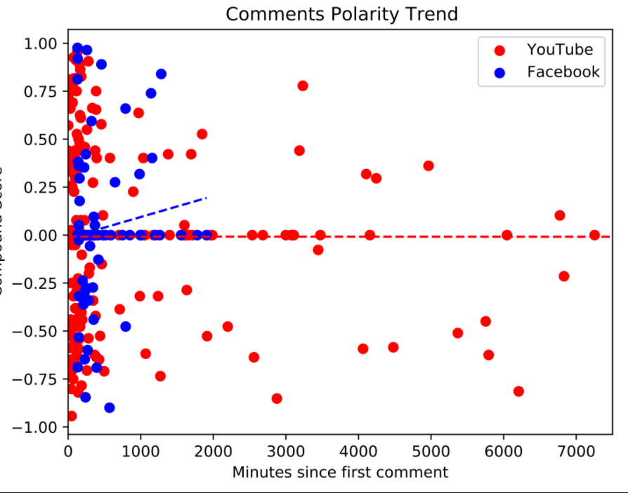

(November)

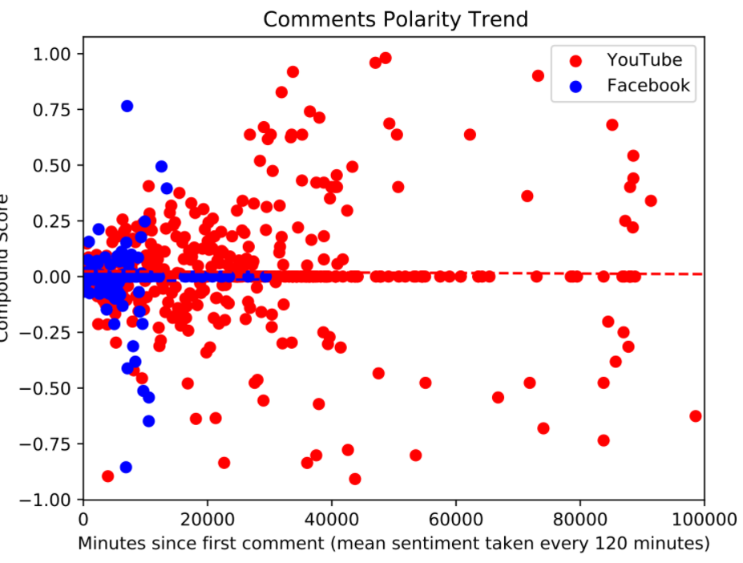

(December)

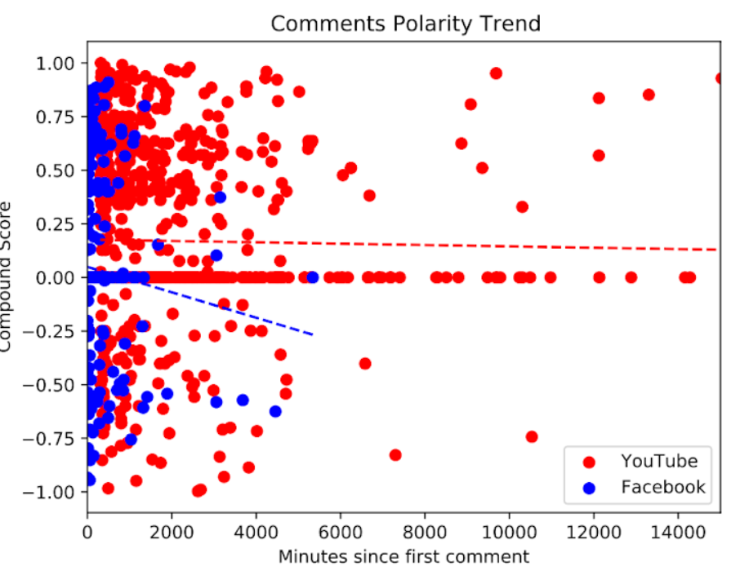

(January: Red Fort Breach)

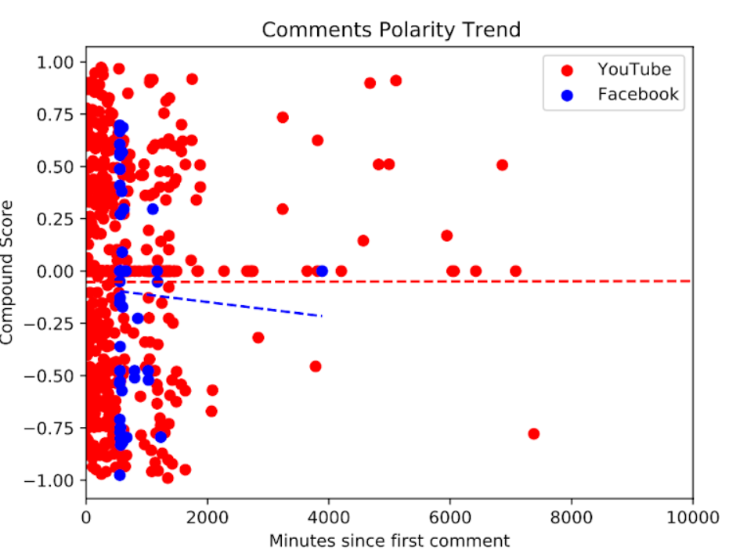

(January: Reality Check)

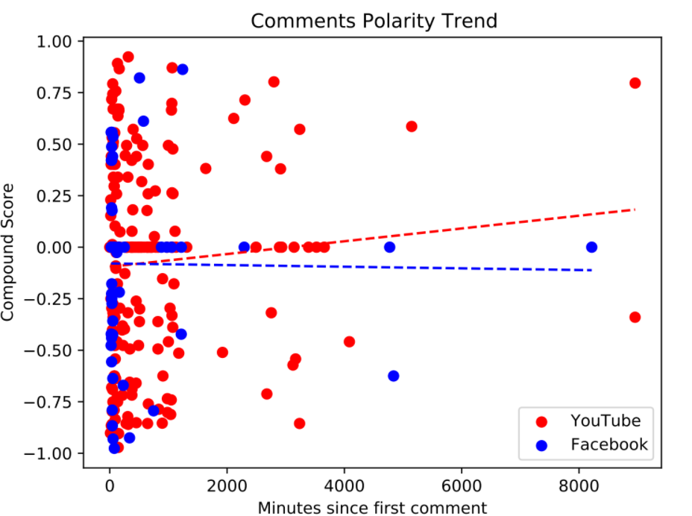

Neeraj Chopra

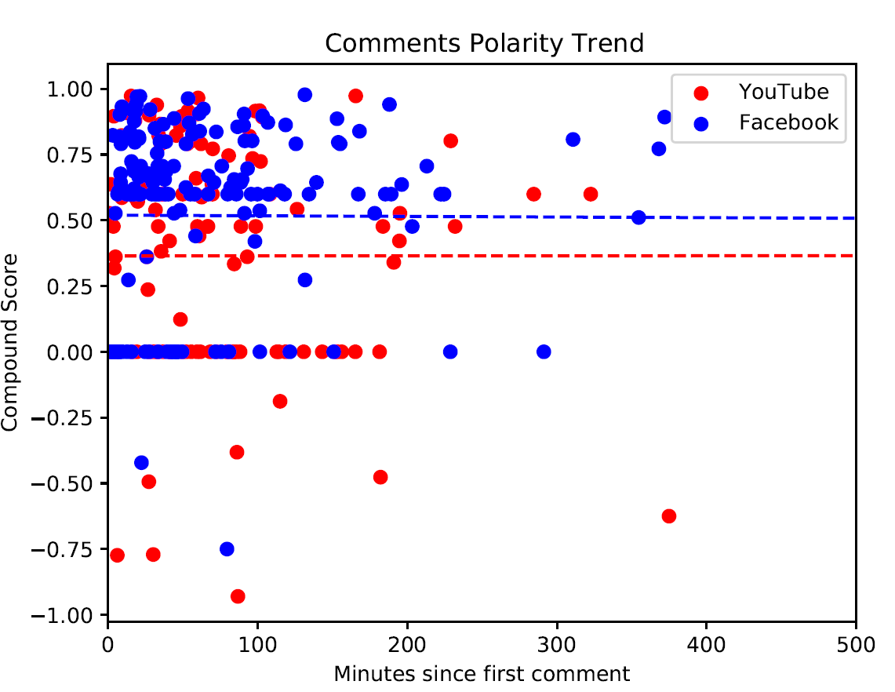

#### Tone Frequency plots

Farmers’ Protest

(September)

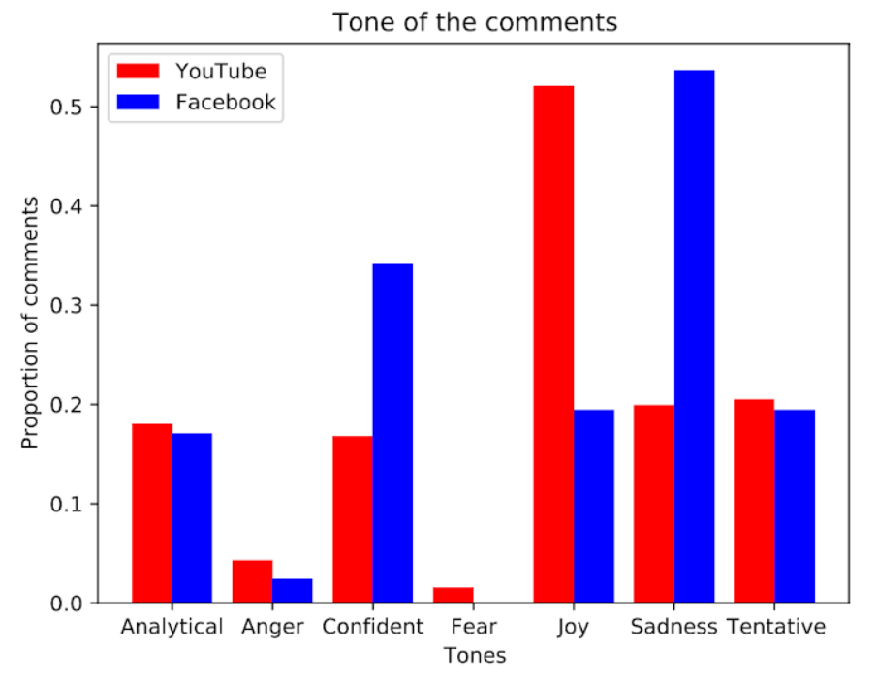

(December)

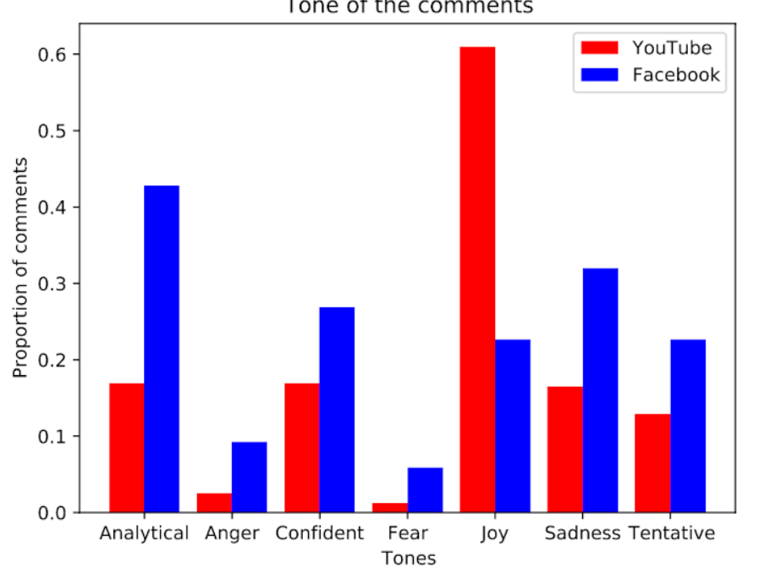

(January: Red Fort Breached)

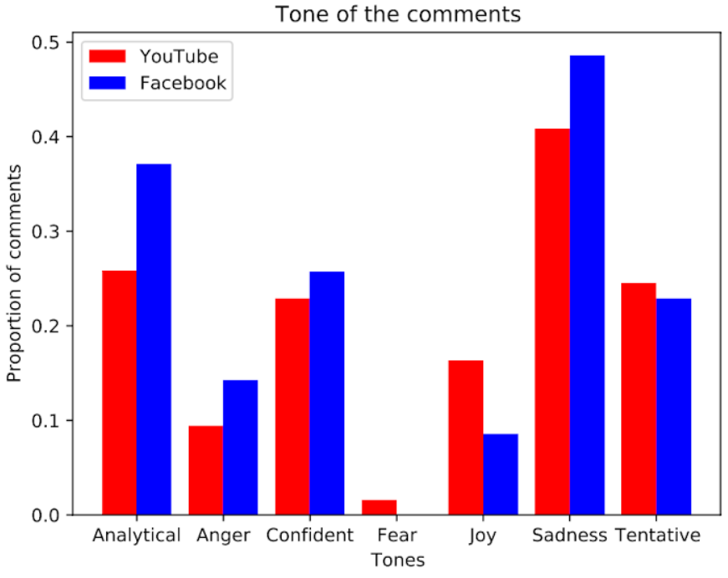

(January: Reality Check)

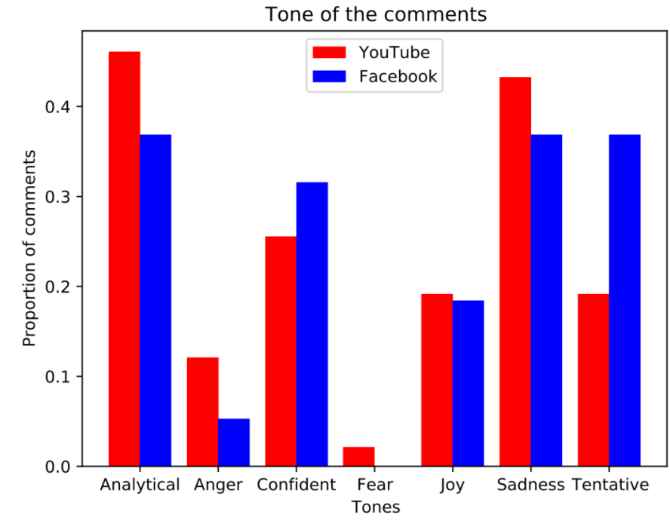

Neeraj Chopra

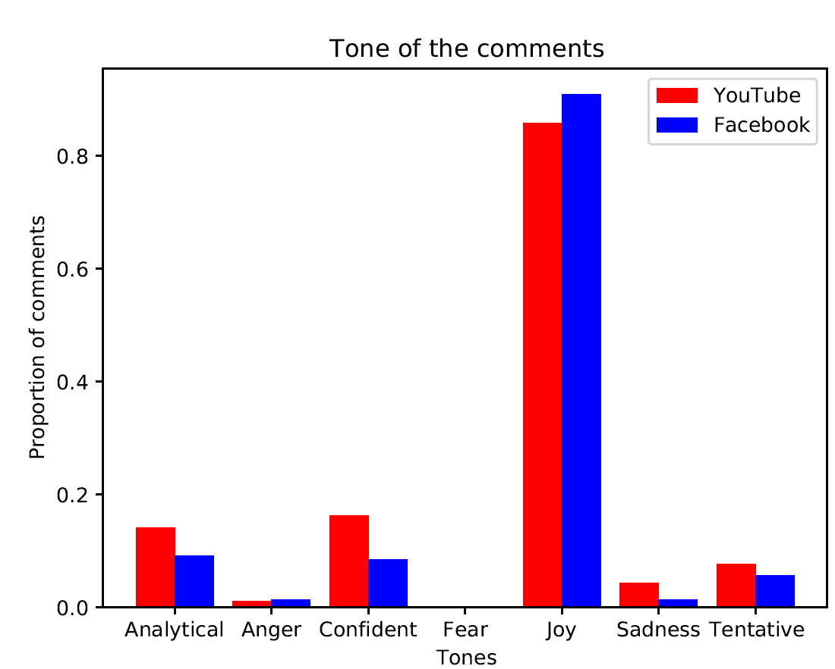

# **Relevance and promotion of healthy discussion**

## **Same platform, different media outlets:**

### Facebook

#### Word Clouds

Sushant Singh Rajput

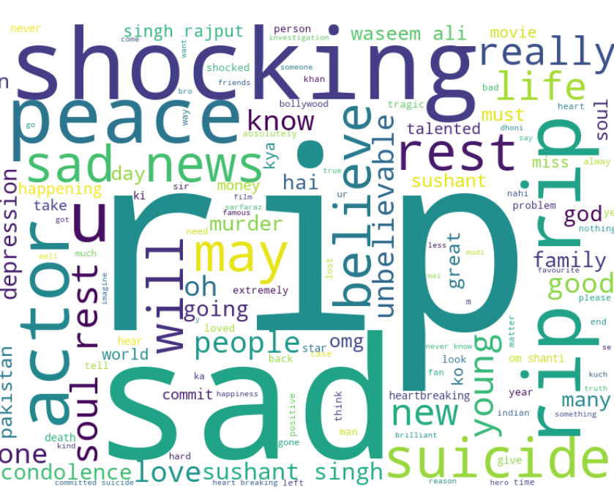India Today Comments

Times Now Comments

Times Now Rhea Chakraborty Comments

India Today Replies

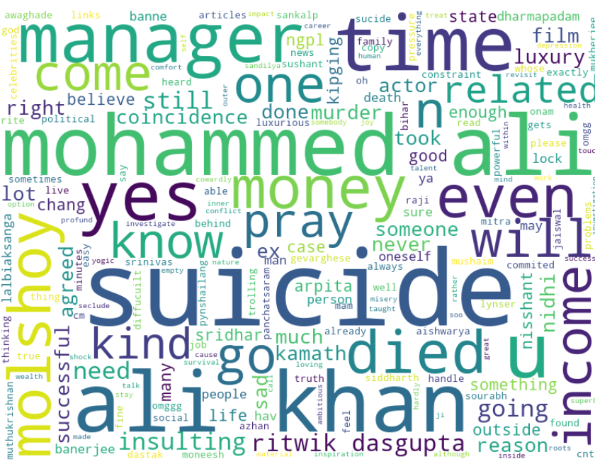Times Now Replies

Farmers’ Protest

#### Word Frequencies

Sushant Singh Rajput

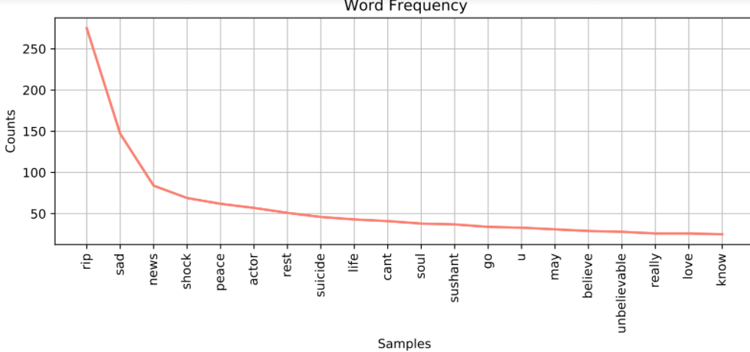India Today Comments

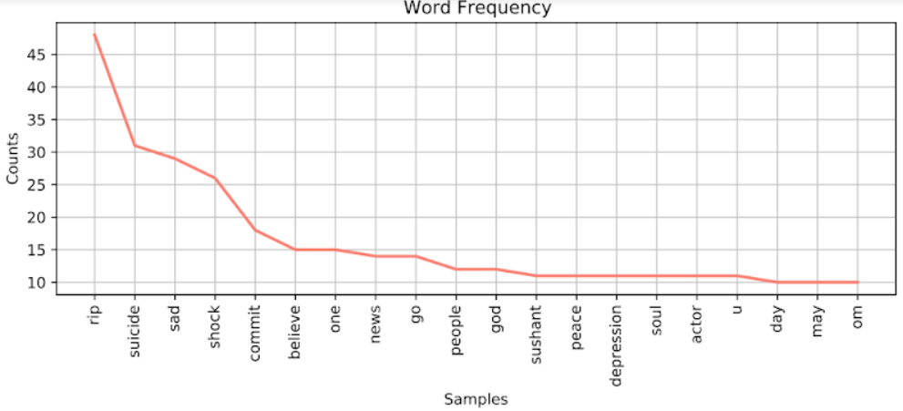Times Now Comments

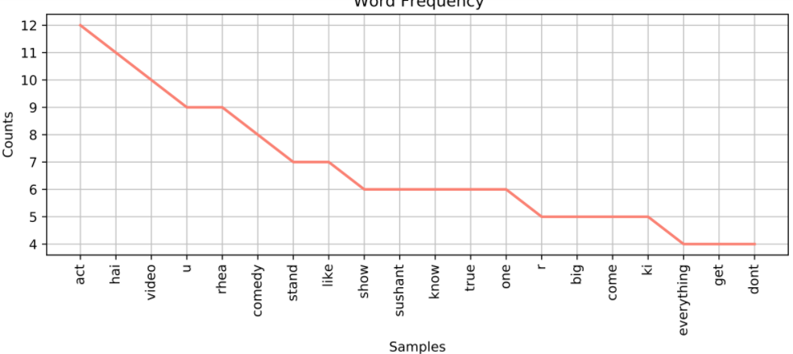Times Now Rhea Chakraborty Comments

Farmers’ Protest

#### Bigrams

Sushant Singh Rajput

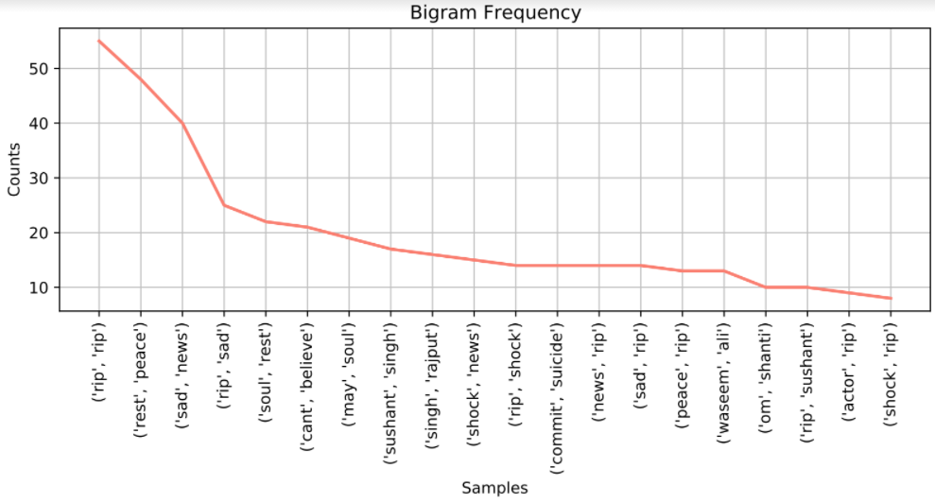India Today Comments

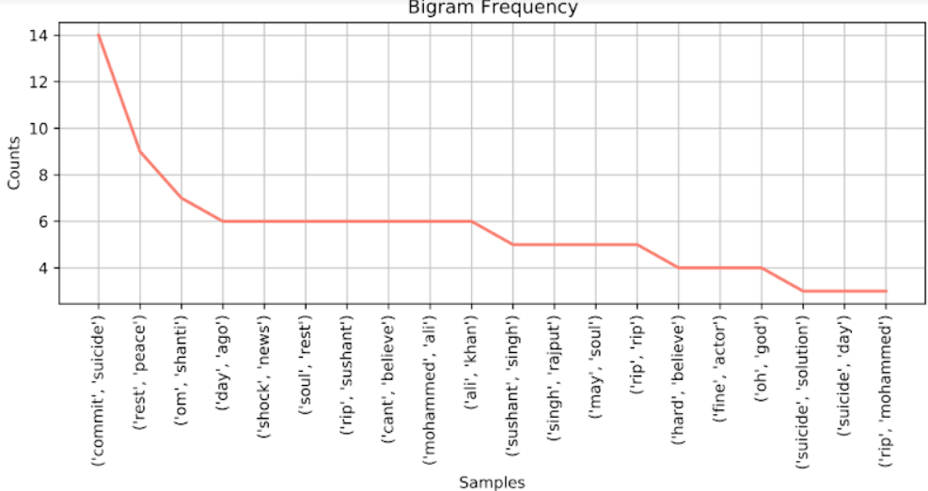Times Now Comments

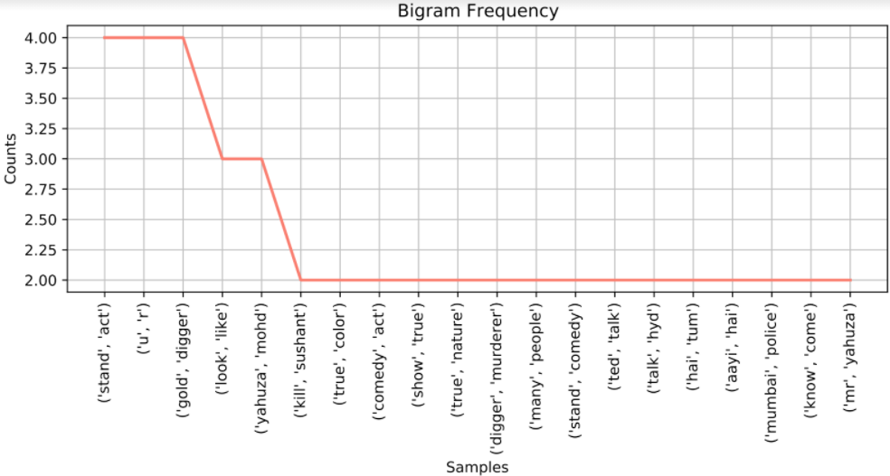Times Now Rhea Chakraborty Comments

Farmers’ Protest

### YouTube

#### Word Clouds

Sushant Singh Rajput

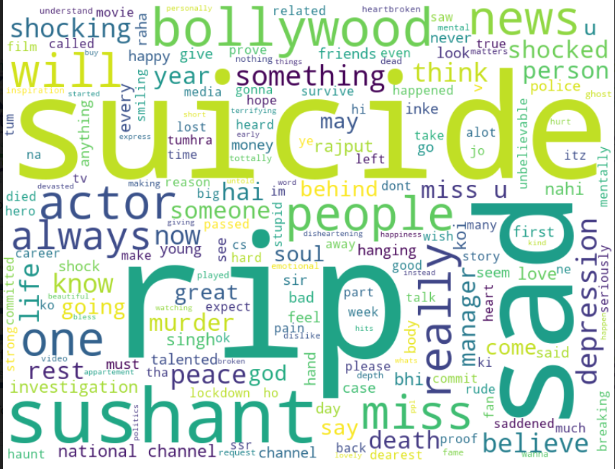India Today Comments

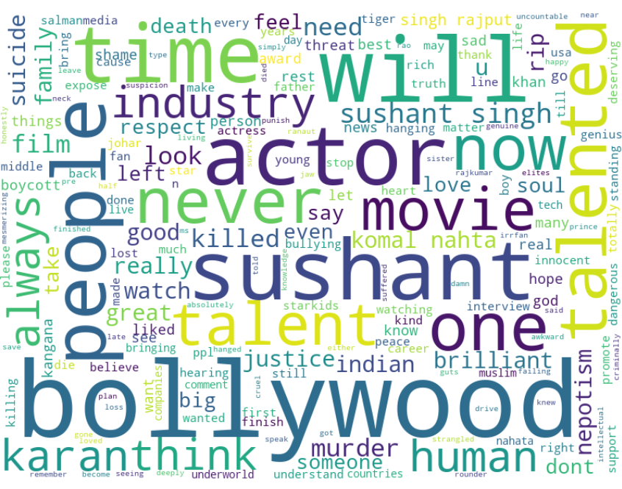Times Now Comments

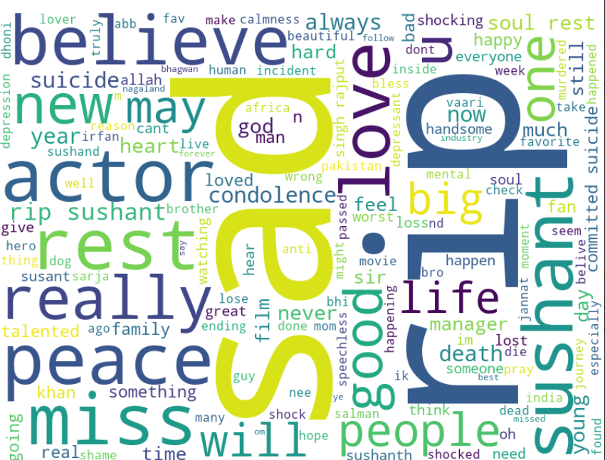NDTV Comments

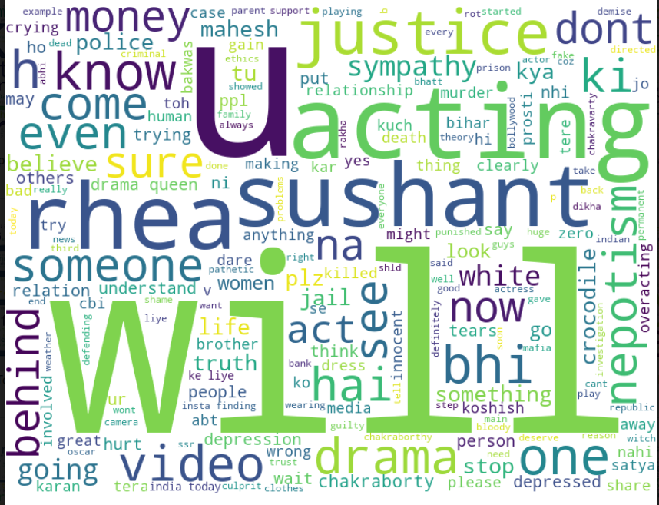India Today Rhea Chakraborty Comments

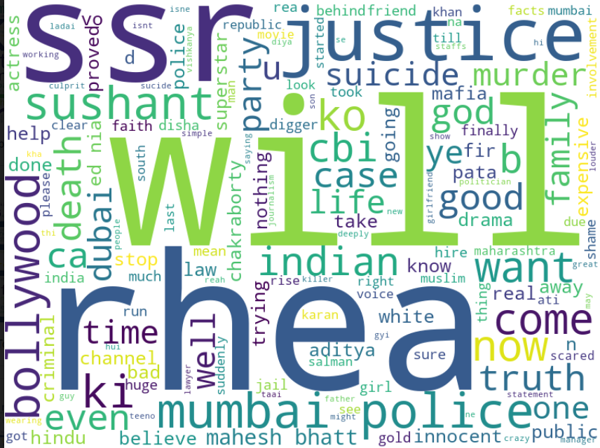Times Now Rhea Chakraborty Comments

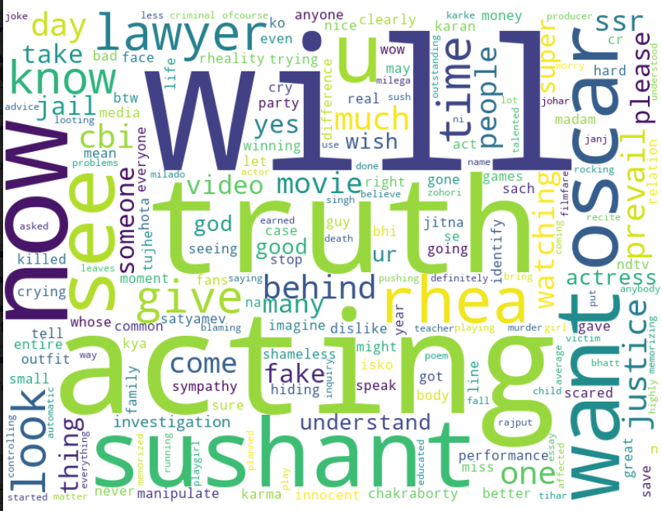NDTV Rhea Chakraborty Comments

Farmers’ Protest

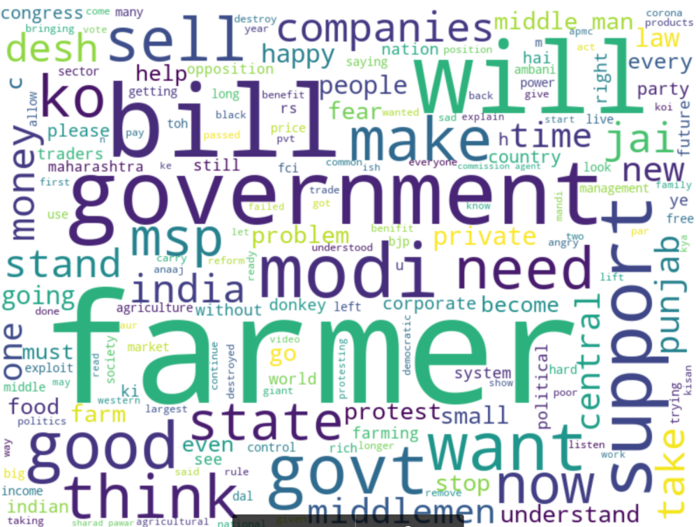India Today September Comments

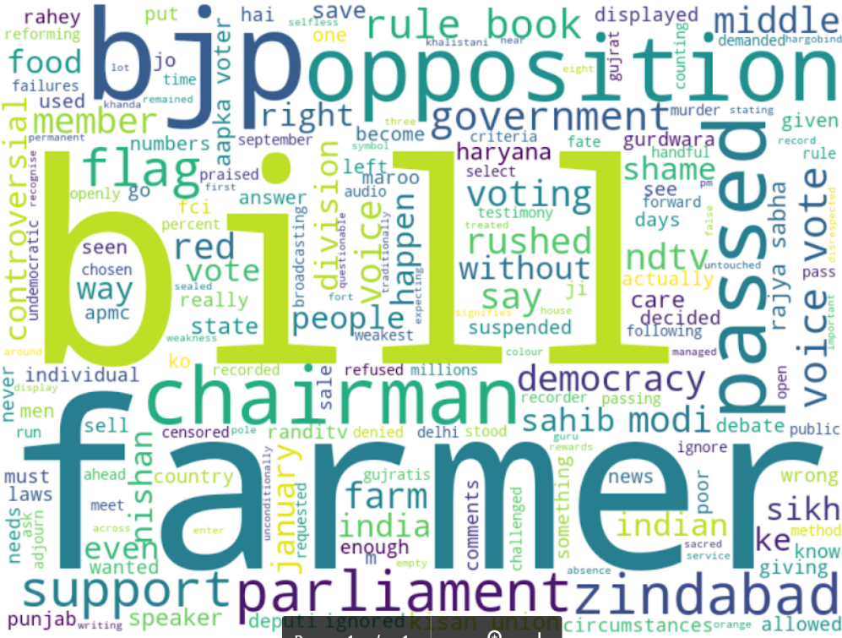NDTV September Comments

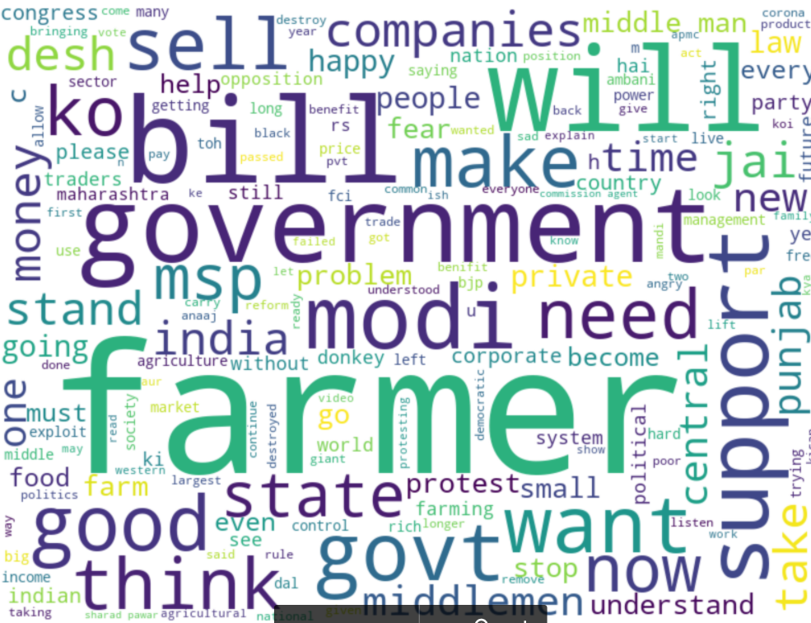India Today September Replies

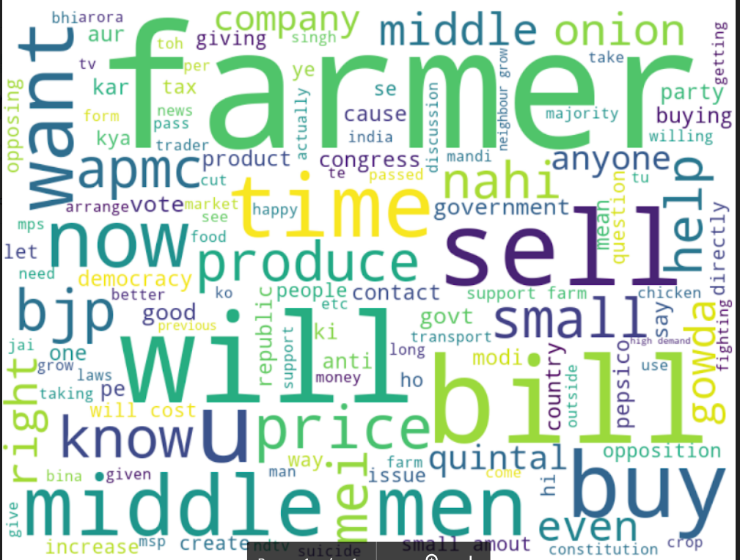NDTV September Replies

#### Word Frequencies

Sushant Singh Rajput

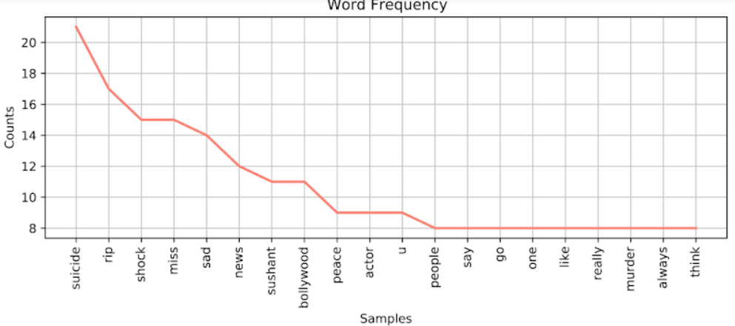India Today Comments

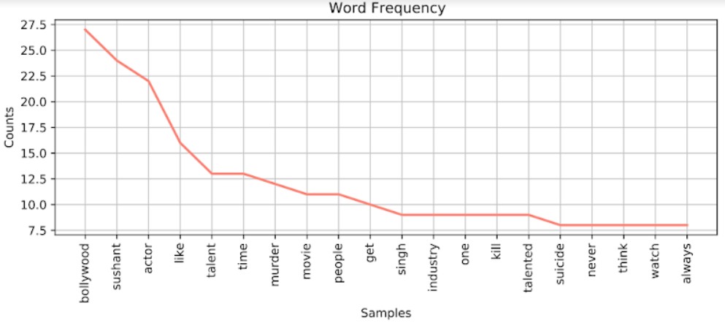Times Now Comments

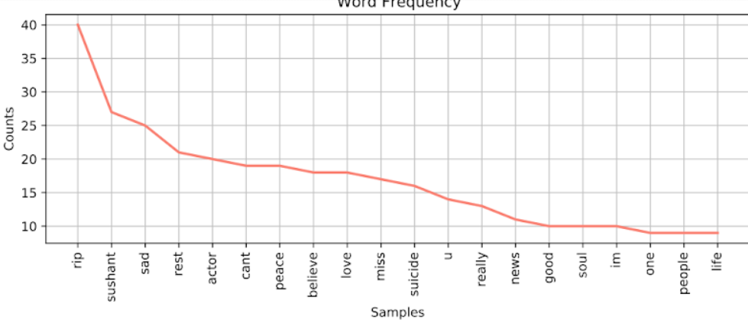NDTV Comments

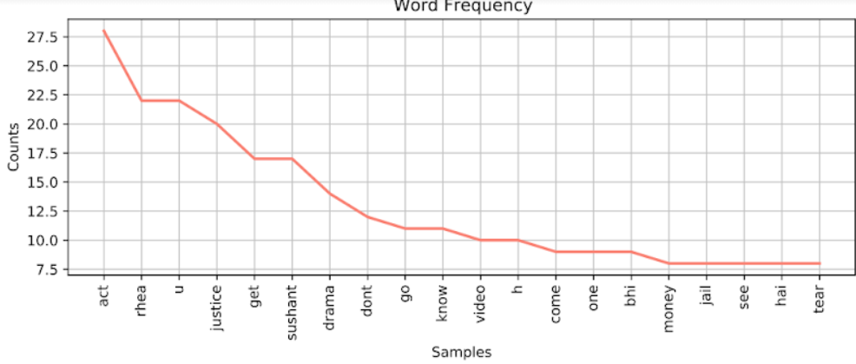India Today Rhea Chakraborty Comments

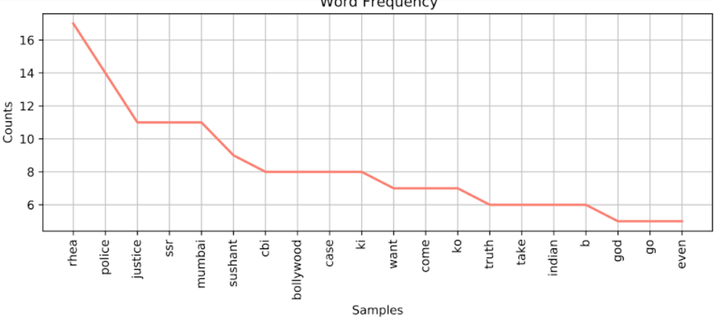Times Now Rhea Chakraborty Comments

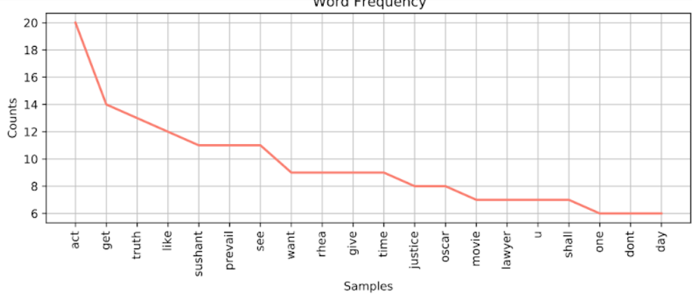NDTV Rhea Chakraborty Comments

Farmers’ Protest

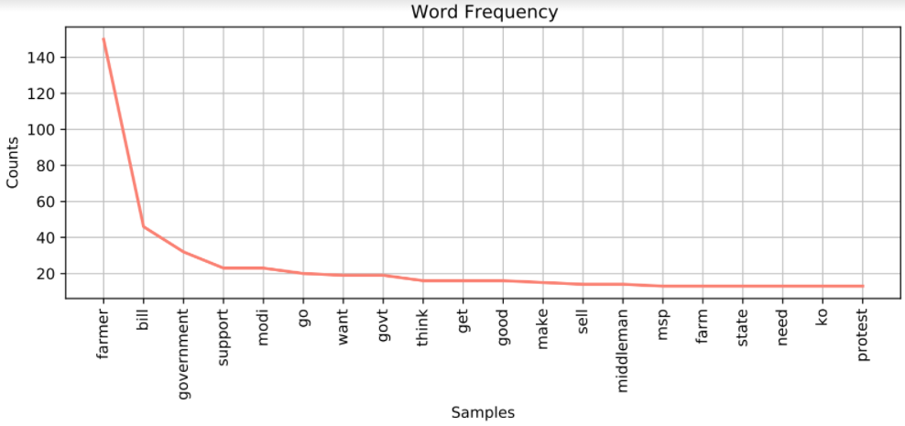India Today September Comments

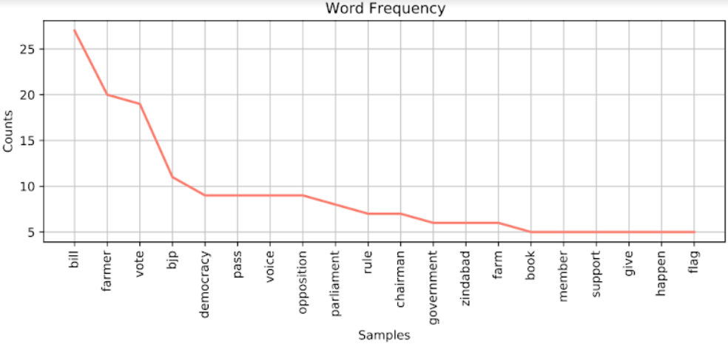NDTV September Comments

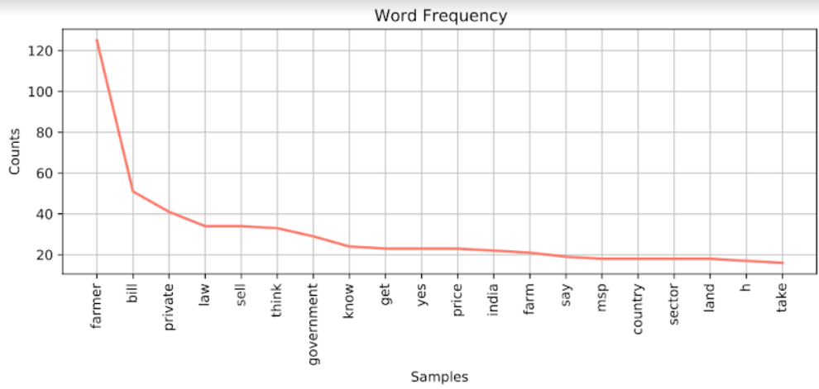India Today September Replies

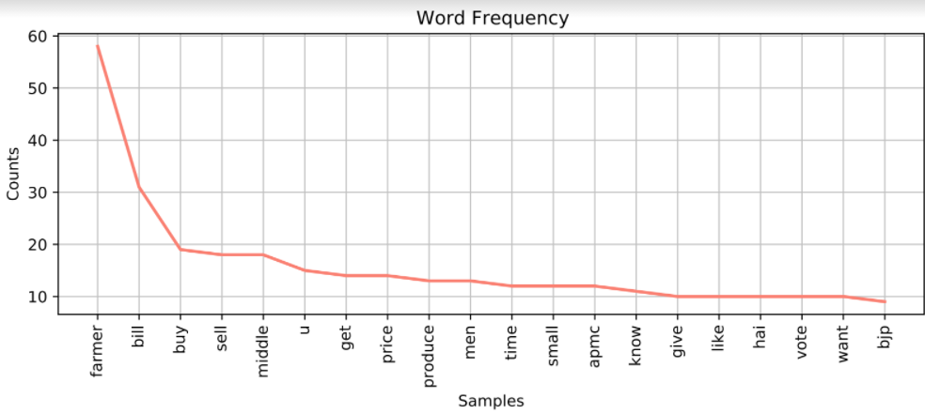NDTV September Replies

#### 

#### Bigrams

Sushant Singh Rajput

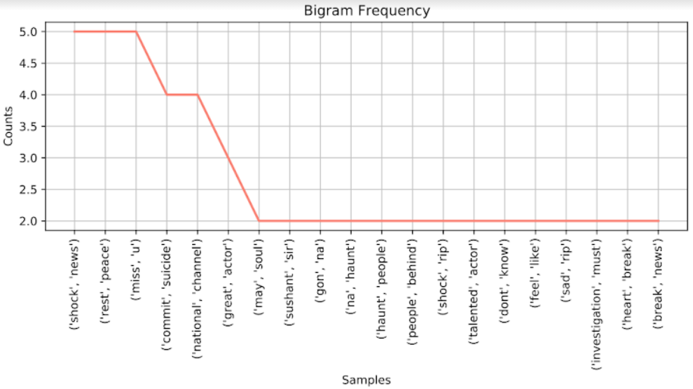India Today Comments

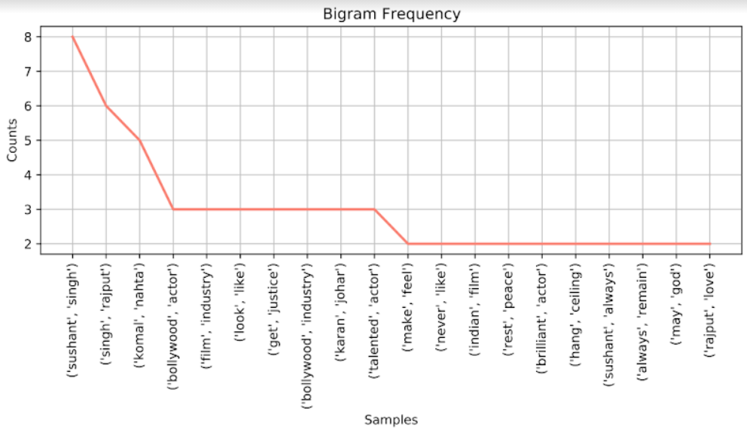Times Now Comments

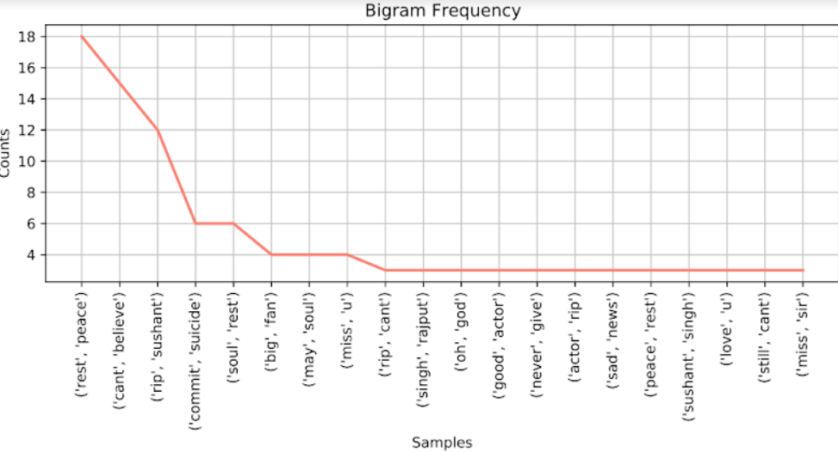NDTV Comments

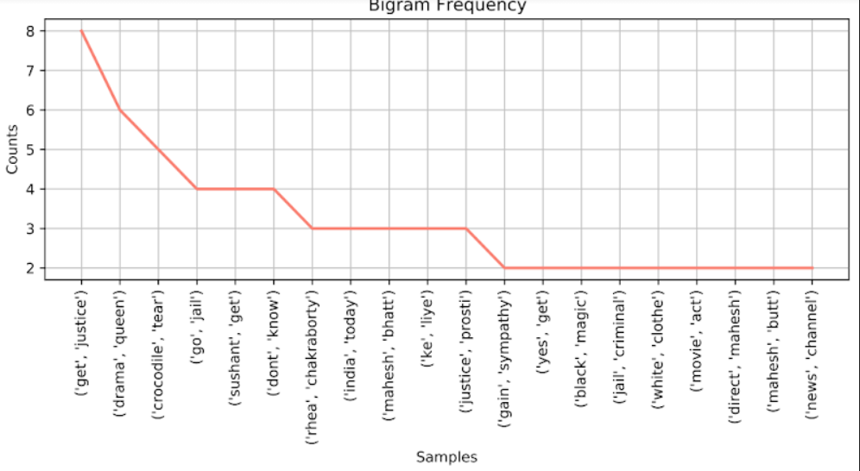India Today Rhea Chakraborty Comments

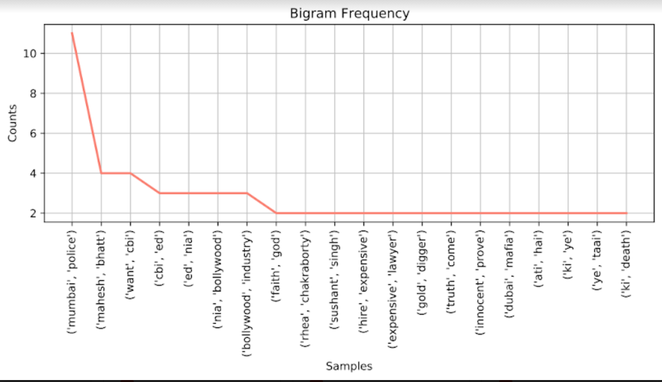Times Now Rhea Chakraborty Comments

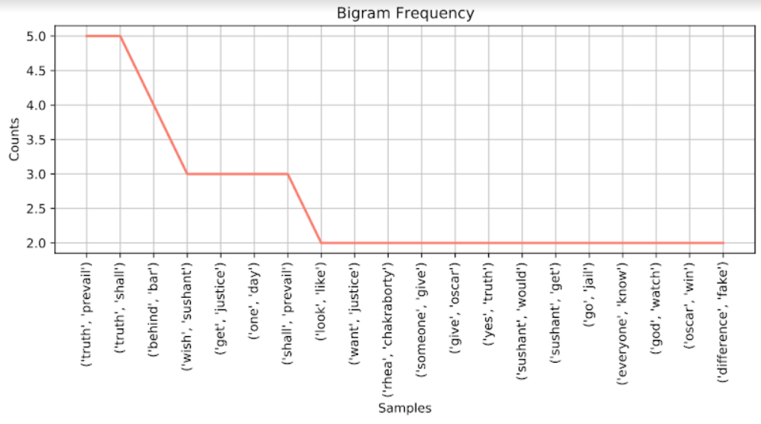NDTV Rhea Chakraborty Comments

Farmers’ Protest

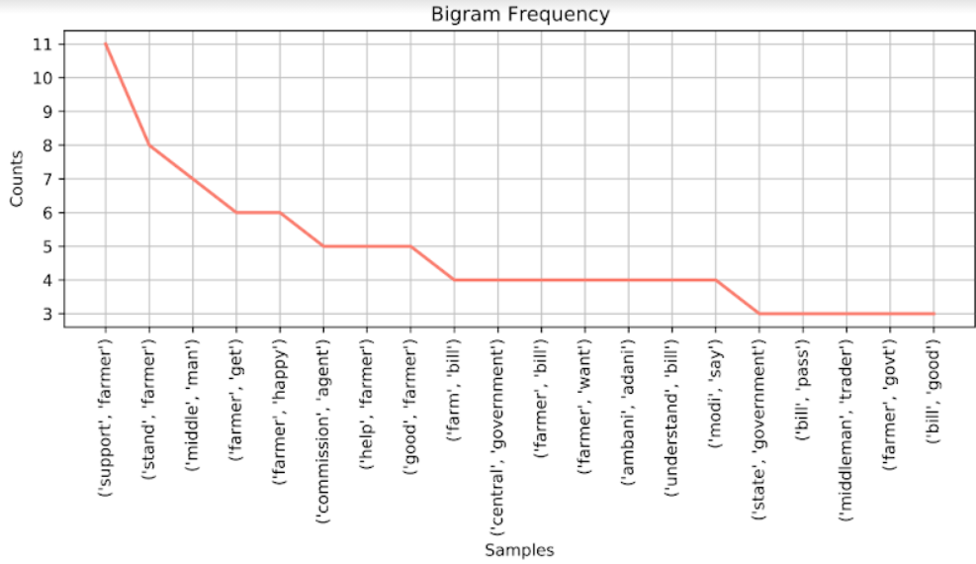India Today September Comments

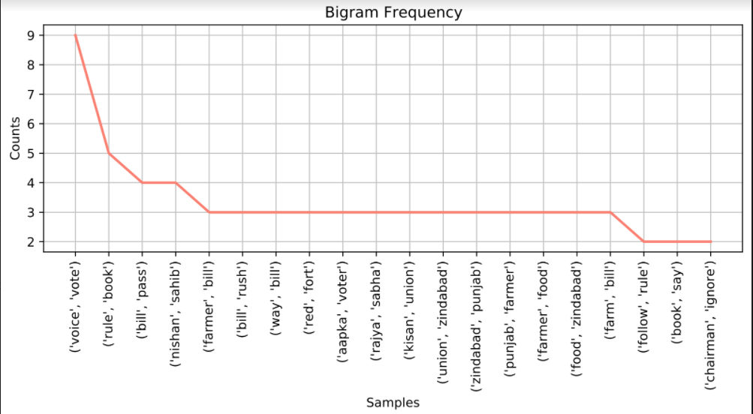NDTV September Comments

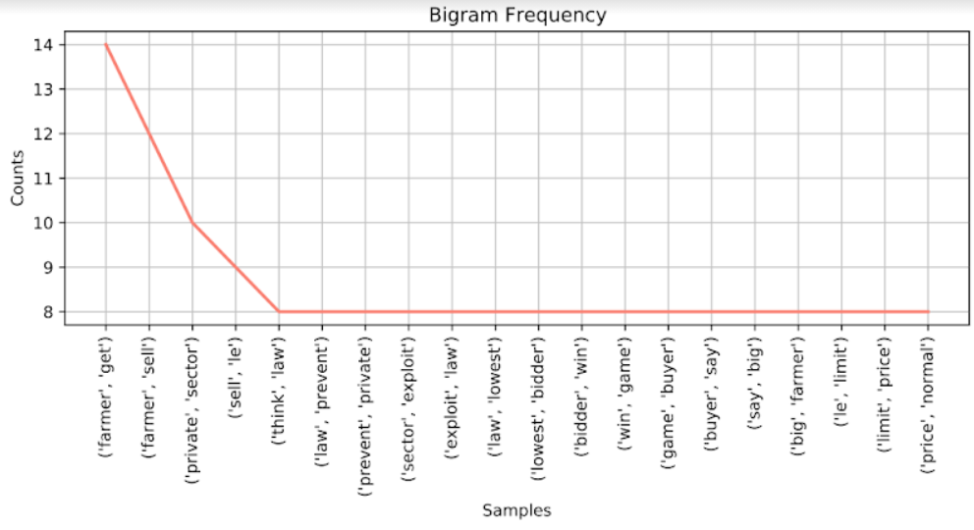India Today September Replies

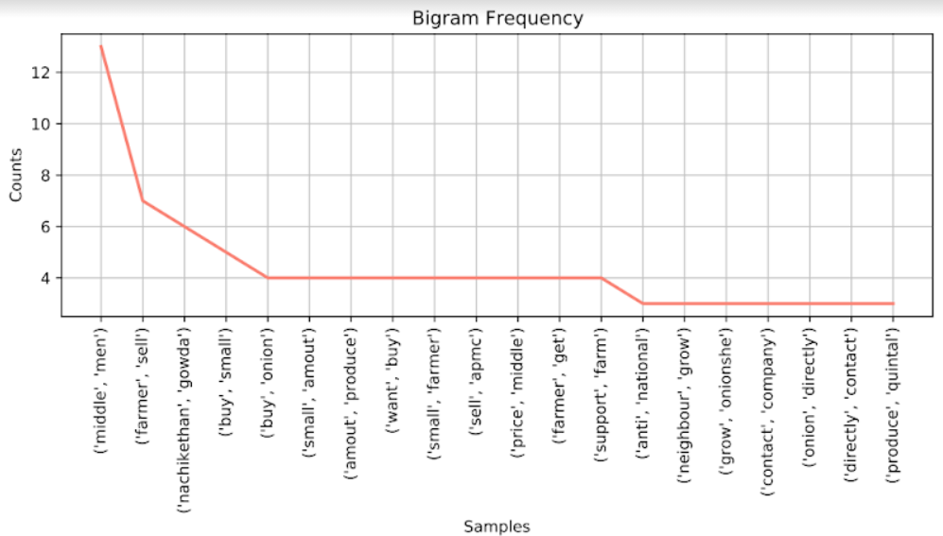NDTV September Replies

## 

## **Different platform, same media outlets:**

(Side by side comparison of plots)

# **Quantity of Engagement**

## **Same platform, different media outlets:**

### **Facebook**

| **Sushant Singh's Suicide Discovered** |  |  |
| --- | --- | --- |
| **Measure** | **Times Now** | **India Today** |
| **Comments** | 204 | 902 |
| **Shares** | 676 | 2581 |
| **Reactions** | 1320 | 9800 |
| Like | 590 | 4966 |
| Love | 0 | 36 |
| Haha | 3 | 26 |
| Wow | 15 | 166 |
| Sad | 707 | 4575 |
| Angry | 5 | 31 |
| **Likes on Comments** | 193 | 374 |
| Ratio wrt to # of comments | 94.61% | 41.46% |
| **Replies on Comments** | 53 | 85 |
| Ratio wrt to # of comments | 35.10% | 10.40% |
| **Comments with more replies than likes** | 9 | 15 |

| **Rhea Chakroborty's First Appearance** |  |  |
| --- | --- | --- |
| **Measure** | **Times Now** | **India Today** |
| **Comments** | 102 | 687 |
| **Shares** |  |  |
| **Reactions** | 570 | 1389 |
| Like | 379 | 275 |
| Love | 8 |  |
| Haha | 13 | 433 |
| Wow | 3 |  |
| Sad | 3 |  |
| Angry | 161 | 645 |
| Care | 3 |  |
| **Likes on Comments** | 121 | 553 |
| Ratio wrt to # of comments | 118.63% | 80.49% |
| **Replies on Comments** | 16 | 56 |
| Ratio wrt to # of comments | 18.60% | 8.87% |
| **Comments with more replies than likes** | 3 | 9 |

| **September** |  |  |
| --- | --- | --- |
| **Measure** | **India Today** | **NDTV** |
| **Comments** | 11 | 74 |
| **Shares** | 4 |  |
| **Reactions** | 129 | 3127 |
| Like | 99 | 2997 |
| Love | 3 | 56 |
| Haha | 16 | 12 |
| Wow | 1 | 6 |
| Sad | 0 | 48 |
| Angry | 0 | 3 |
| **Likes on Comments** | 4 | 130 |
| Ratio wrt to # of comments | 36.36% | 175.68% |
| **Replies on Comments** | 10 | 68 |
| Ratio wrt to # of comments | 90.91% | 91.89% |
| **Comments with more replies than likes** | 2 | 7 |

| **November: Dhaba offers free food** |  |  |
| --- | --- | --- |
| **Measure** | **India Today** | **NDTV** |
| **Comments** | 80 | 665 |
| **Shares** | 123 |  |
| **Reactions** | 1886 | 37510 |
| Like | 1625 | 34313 |
| Love | 209 | 2793 |
| Haha | 24 | 71 |
| Wow | 3 | 72 |
| Sad | 0 | 8 |
| Angry | 5 | 21 |
| **Likes on Comments** | 261 | 780 |
| Ratio wrt to # of comments | 326.25% | 117.29% |
| **Replies on Comments** | 162 | 350 |
| Ratio wrt to # of comments | 202.50% | 52.63% |
| **Comments with more replies than likes** | 12 | 25 |

| **December: Bharat Bandh** |  |  |
| --- | --- | --- |
| **Measure** | **India Today** | **NDTV** |
| **Comments** | 85 | 202 |
| **Shares** | 54 | 671 |
| **Reactions** | 1369 | 7613 |
| Like | 1149 | 6849 |
| Love | 109 | 577 |
| Haha | 83 | 83 |
| Wow | 4 | 29 |
| Sad | 7 | 6 |
| Angry | 16 | 33 |
| **Likes on Comments** | 281 | 613 |
| Ratio wrt to # of comments | 330.59% | 303.47% |
| **Replies on Comments** | 188 | 302 |
| Ratio wrt to # of comments | 221.18% | 149.50% |
| **Comments with more replies than likes** | 15 | 20 |

| **January: Red Fort approach** |  |  |
| --- | --- | --- |
| **Measure** | **India Today** | **NDTV** |
| **Comments** | 106 | 81 |
| **Shares** | 58 |  |
| **Reactions** | 766 | 526 |
| Like | 507 | 417 |
| Love | 118 | 43 |
| Haha | 10 | 10 |
| Wow | 0 | 1 |
| Sad | 4 | 15 |
| Angry | 119 | 37 |
| **Likes on Comments** | 106 | 85 |
| Ratio wrt to # of comments | 100.00% | 104.94% |
| **Replies on Comments** | 148 | 83 |
| Ratio wrt to # of comments | 139.62% | 102.47% |
| **Comments with more replies than likes** | 23 | 17 |

| **January: SFJ** |  |  |
| --- | --- | --- |
| **Measure** | **India Today** | **NDTV** |
| **Comments** | 171 | 162 |
| **Shares** | 72 | 46 |
| **Reactions** | 519 | 737 |
| Like | 196 | 296 |
| Love | 13 | 6 |
| Haha | 178 | 212 |
| Wow | 6 | 5 |
| Sad | 0 | 16 |
| Angry | 125 | 202 |
| **Likes on Comments** | 246 | 419 |
| Ratio wrt to # of comments | 143.86% | 258.64% |
| **Replies on Comments** | 206 | 125 |
| Ratio wrt to # of comments | 120.47% | 77.16% |
| **Comments with more replies than likes** | 18 | 13 |

| **Neeraj Chopra** |  |  |
| --- | --- | --- |
| **Measure** | **India Today** | **NDTV** |
| **Comments** | 455 | 256 |
| **Shares** |  |  |
| **Reactions** | 44637 | 12842 |
| Like | 40283 | 11461 |
| Love | 4060 | 1295 |
| Haha | 13 | 7 |
| Wow | 61 | 22 |
| Sad | 2 | 0 |
| Angry | 7 | 2 |
| **Likes on Comments** | 119 | 58 |
| Ratio wrt to # of comments | 26.15% | 22.66% |
| **Replies on Comments** | 49 | 13 |
| Ratio wrt to # of comments | 10.77% | 5.08% |
| **Comments with more replies than likes** | 11 | 1 |

### **YouTube**

| **Sushant Singh's Suicide Discovered** |  |  |  |  |
| --- | --- | --- | --- | --- |
| **Measure** | **Times Now** | **India Today** | **NDTV (English)** | **NDTV (Hindi)** |
| **Comments** | 1176 | 215 | 886 | 1451 |
| **Views** | 403003 | 346013 | 1237085 | 1181187 |
| **Likes** | 5929 | 1755 | 7050 | 10535 |
| **Dislikes** | 222 | 155 | 590 | 786 |
| **Likes on Comments** | 5624 | 426 | 2194 | 3980 |
| Ratio wrt to # of comments | 478.23% | 198.14% | 247.63% | 274.29% |
| **Replies on Comments** | 197 | 56 | 110 | 255 |
| Ratio wrt to # of comments | 20.12% | 35.22% | 14.18% | 21.32% |
| **Comments with more replies than likes** | 0 | 3 | 0 | 2 |

| **Rhea Chakrobarty first appearance** |  |  |  |
| --- | --- | --- | --- |
| **Measure** | **Times Now** | **India Today** | **NDTV** |
| **Comments** | 96 | 204 | 2038 |
| **Views** | 15012 | 21961 | 248226 |
| **Likes** | 112 | 109 | 1213 |
| **Dislikes** | 37 | 263 | 7305 |
| **Likes on Comments** | 217 | 634 | 4180 |
| Ratio wrt to # of comments | 226.04% | 310.78% | 205.10% |
| **Replies on Comments** | 23 | 17 | 125 |
| Ratio wrt to # of comments | 31.51% | 9.09% | 6.53% |
| **Comments with more replies than likes** | 1 | 0 | 0 |

| **September** |  |  |
| --- | --- | --- |
| **Measure** | **India Today** | **NDTV** |
| **Comments** | 133 | 803 |
| **Views** | 77097 | 643361 |
| **Likes** | 1509 | 17350 |
| **Dislikes** | 106 | 1027 |
| **Likes on Comments** | 736 | 3755 |
| Ratio wrt to # of comments | 553.38% | 467.62% |
| **Replies on Comments** | 145 | 449 |
| Ratio wrt to # of comments | 109.02% | 55.92% |
| **Comments with more replies than likes** | 11 | 14 |

| **November** |  |  |
| --- | --- | --- |
| **Measure** | **India Today** | **NDTV** |
| **Comments** | 50 | 749 |
| **Views** | 12042 | 353302 |
| **Likes** | 210 | 11360 |
| **Dislikes** | 28 | 467 |
| **Likes on Comments** | 56 | 3499 |
| Ratio wrt to # of comments | 112.00% | 467.16% |
| **Replies on Comments** | 6 | 299 |
| Ratio wrt to # of comments | 12.00% | 39.92% |
| **Comments with more replies than likes** | 1 | 25 |

| **December** |  |  |
| --- | --- | --- |
| **Measure** | **India Today** | **NDTV** |
| **Comments** | 100 | 1079 |
| **Views** | 42093 | 606056 |
| **Likes** | 360 | 18503 |
| **Dislikes** | 71 | 711 |
| **Likes on Comments** | 289 | 4619 |
| Ratio wrt to # of comments | 289.00% | 428.08% |
| **Replies on Comments** | 34 | 345 |
| Ratio wrt to # of comments | 34.00% | 31.97% |
| **Comments with more replies than likes** | 3 | 17 |

| **January** |  |  |
| --- | --- | --- |
| **Measure** | **India Today** | **NDTV** |
| **Comments** | 1384 | 445 |
| **Views** | 1284520 | 278052 |
| **Likes** | 13988 | 3979 |
| **Dislikes** | 2975 | 515 |
| **Likes on Comments** | 3796 | 1080 |
| Ratio wrt to # of comments | 274.28% | 242.70% |
| **Replies on Comments** | 908 | 289 |
| Ratio wrt to # of comments | 65.61% | 64.94% |
| **Comments with more replies than likes** | 90 | 37 |

| **January (Barricade breaking)** |  |  |
| --- | --- | --- |
| **Measure** | **India Today** | **NDTV** |
| **Comments** | 591 | 414 |
| **Views** | 350388 | 208834 |
| **Likes** | 4082 | 3108 |
| **Dislikes** | 820 | 436 |
| **Likes on Comments** | 2258 | 1909 |
| Ratio wrt to # of comments | 382.06% | 461.11% |
| **Replies on Comments** | 509 | 528 |
| Ratio wrt to # of comments | 86.13% | 127.54% |
| **Comments with more replies than likes** | 52 | 33 |

| **January (Stone pelting/tear gas)** |  |  |
| --- | --- | --- |
| **Measure** | **India Today** | **NDTV** |
| **Comments** | 662 | 194 |
| **Views** | 238368 | 53803 |
| **Likes** | 2294 | 942 |
| **Dislikes** | 761 | 102 |
| **Likes on Comments** | 2256 | 851 |
| Ratio wrt to # of comments | 340.79% | 438.66% |
| **Replies on Comments** | 604 | 194 |
| Ratio wrt to # of comments | 91.24% | 100.00% |
| **Comments with more replies than likes** | 42 | 17 |

| **January (Debate)** |  |  |
| --- | --- | --- |
| **Measure** | **India Today** | **NDTV** |
| **Comments** | 137 | 2225 |
| **Views** | 43885 | 411822 |
| **Likes** | 304 | 19324 |
| **Dislikes** | 210 | 3310 |
| **Likes on Comments** | 217 | 6702 |
| Ratio wrt to # of comments | 158.39% | 301.21% |
| **Replies on Comments** | 77 | 1384 |
| Ratio wrt to # of comments | 56.20% | 62.20% |
| **Comments with more replies than likes** | 25 | 107 |

| **Neeraj Chopra** |  |  |
| --- | --- | --- |
| **Measure** | **India Today** | **NDTV** |
| **Comments** | 339 | 126 |
| **Views** | 430841 | 75099 |
| **Likes** | 5679 | 1994 |
| **Dislikes** | 157 | 56 |
| **Likes on Comments** | 1902 | 637 |
| Ratio wrt to # of comments | 561.06% | 505.56% |
| **Replies on Comments** | 83 | 74 |
| Ratio wrt to # of comments | 24.48% | 58.73% |
| **Comments with more replies than likes** | 2 | 6 |

## **Different platform, same media outlets:**

### **India Today**

| **Sushant Singh's Suicide Discovered** |  |  |  |
| --- | --- | --- | --- |
| **Measure** | **YouTube** | **Facebook** | **Measure** |
| **Comments** | 215 | 902 | **Comments** |
| **Views** | 346013 | 2581 | **Shares** |
| **Likes** | 1755 | 9800 | **Reactions** |
| **Dislikes** | 155 | 4966 | Like |
|  |  | 36 | Love |
|  |  | 26 | Haha |
|  |  | 166 | Wow |
|  |  | 4575 | Sad |
|  |  | 31 | Angry |
| **Likes on Comments** | 426 | 374 | **Likes on Comments** |
| Ratio wrt to # of comments | 198.14% | 41.46% | Ratio wrt to # of comments |
| **Replies on Comments** | 56 | 85 | **Replies on Comments** |
| Ratio wrt to # of comments | 35.22% | 10.40% | Ratio wrt to # of comments |
| **Comments with more replies than likes** | 3 | 15 | **Comments with more replies than likes** |

### **Times Now**

| **Sushant Singh's Suicide Discovered** |  |  |  |
| --- | --- | --- | --- |
| **Measure** | **YouTube** | **Facebook** | **Measure** |
| **Comments** | 1176 | 204 | **Comments** |
| **Views** | 403003 | 676 | **Shares** |
| **Likes** | 5929 | 1320 | **Reactions** |
| **Dislikes** | 222 | 590 | Like |
|  |  | 0 | Love |
|  |  | 3 | Haha |
|  |  | 15 | Wow |
|  |  | 707 | Sad |
|  |  | 5 | Angry |
| **Likes on Comments** | 5624 | 193 | **Likes on Comments** |
| Ratio wrt to # of comments | 478.23% | 94.61% | Ratio wrt to # of comments |
| **Replies on Comments** | 197 | 53 | **Replies on Comments** |
| Ratio wrt to # of comments | 20.12% | 35.10% | Ratio wrt to # of comments |
| **Comments with more replies than likes** | 0 | 9 | **Comments with more replies than likes** |

### 

| **Rhea Chakroborty's First Appearance** |  |  |  |
| --- | --- | --- | --- |
| **Measure** | **YouTube** | **Facebook** | **Measure** |
| **Comments** | 96 | 102 | **Comments** |
| **Views** | 15012 |  | **Shares** |
| **Likes** | 112 | 570 | **Reactions** |
| **Dislikes** | 37 | 379 | Like |
|  |  | 8 | Love |
|  |  | 13 | Haha |
|  |  | 3 | Wow |
|  |  | 3 | Sad |
|  |  | 161 | Angry |
| **Likes on Comments** | 217 | 121 | **Likes on Comments** |
| Ratio wrt to # of comments | 226.04% | 118.63% | Ratio wrt to # of comments |
| **Replies on Comments** | 23 | 1600.00% | **Replies on Comments** |
| Ratio wrt to # of comments | 31.51% | 18.60% | Ratio wrt to # of comments |
| **Comments with more replies than likes** | 1 | 3 | **Comments with more replies than likes** |

### 

### **NDTV**

# **Quality of Engagement**

## Ratioed Comments

### Facebook

(Check folder)

### YouTube

(Check folder)

# **Transcriptions**

## **Facebook**

| **Character** | **India Today Rhea Chakraborty** | **Times Now Rhea Chakraborty** |
| --- | --- | --- |
| Captions/Anchor | -0.9803 | 0.938 |
| Rhea (video)/Madhav (senior editor) | 0.7351 | 0.6856 |
| Comments | -0.07807044146 | 0.06314556962 |

| **Character** | **India Today Neeraj Chopra** | **NDTV Neeraj Chopra** |
| --- | --- | --- |
| Captions/Anchor | 0.9816 | 0.9628 |
| Neeraj Mother/Rupinder | 0.6115 | 0.9836 |
| Neeraj Sister/Reporter | 0.9286 | 0.1531 |
| Person |  | 0.8979 |
| Comments | 0.4733440722  (0.64668) | 0.4974172897  (0.65305) |

## **YouTube**

| **Character** | **India Today SSR** | **Times Now SSR** |
| --- | --- | --- |
| Anchor | -0.9671 | -0.9702 |
| Inspector/Vani Tripathi | -0.8621 | 0.9844 |
| Reporter1/Roopa Ganguly | 0.918 | 0.9081 |
| Kranti Prakash Jha/Komal Nahta | 0.3998 | -0.1326 |
| Kubbra Sait/Anand | 0.5782 | 0.9846 |
| Kunal Kohli | -0.6374 |  |
| Hiten Tejwani | 0.8375 |  |
| Reporter 2 | -0.912 |  |
| Sushant Mehta | -0.9862 |  |
| Sushant Mehta(2019) | 0.9431 |  |
| SSR (2019) | 0.9244 |  |
| Comments | -0.09980066225 | 0.049405 |

| **Character** | **India Today Rhea Chakraborty** | **Times Now Rhea Chakraborty** |
| --- | --- | --- |
| Reporter | 0.782 | 0.9421 |
| Sushant Mehta/Kajal | -0.9859 | 0 |
| Siddhanth (Reporter) |  | 0.3612 |
| Reporter #2 |  | -0.594 |
| Chartered Accountant |  | 0.9489 |
| Swapnil |  | 0.8719 |
| Ravi |  | -0.3919 |
| Aniket |  | -0.9731 |
| Shekhar Suman |  | -0.9088 |
| Comments | -0.006611042945 | -0.05101290323 |

| **Character** | **India Today Neeraj Chopra** | **NDTV Neeraj Chopra** |
| --- | --- | --- |
| Anchor | 0.9525 | 0.9719 |
| Reporter | 0.9589 |  |
| Comment | 0.3686436578  (0.55542) | 0.3648642857  (0.53456) |